Advancing Education Practices in High Performance Buildings: Bridging the Skills Gap Between Academia and Professional Careers through Practical BEAM Plus Project Experience
Tim LO^{1*}, Yahong DONG² and Gary CHU³
¹ BEAM Society Limited, Hong Kong SAR, China
² Department of Environmental Science and Engineering, Macau University of Science and Technology, Macau SAR, China
² New Vector Engineering Design & Consultancy Co., Ltd., Macau SAR, China

*E-mail: timlo@beamsociety.org.hk

Abstract. A core mission of the BEAM Society (BSL) is to advance sustainable, healthy and high-performance buildings. While academic programs provide theoretical knowledge, a significant skills gap often remains, as graduates typically lack the practical, project-based experience needed for real-world green building certification and consultancy. The BEAM Plus certification process is collaborative and iterative, requiring skills such as managing revision cycles, executing value engineering and adapting to dynamic policies within a multi-disciplinary team. To bridge this gap and develop a higher-quality workforce, the BSL, in collaboration with the Macau University of Science and Technology (MUST), launched an innovative pilot project. This initiative allowed MUST’s research students to engage in a genuine BEAM Plus assessment for a campus building, effectively acting as green building consultants and project managers. Guided by professors, facility managers, and engineering consultants, the students participated in workshops, consulting meetings, on-site monitoring and green building management planning. The success of this pilot project at MUST has set a model for how the BSL supports green building development by cultivating skilled students, offering a replicable benchmark for educational partnerships that ensure the industry is equipped with a practice-ready workforce to drive sustainable transformation in the built environment.
1. Introduction
In the face of escalating environmental challenges, the construction and operation of buildings have come under increased scrutiny, emphasizing the need for a credible certification framework and consultation by knowledgeable professionals. The BEAM Society (BSL) has emerged as a pivotal force in promoting high-quality building construction and practices through its BEAM Plus certification, which serves as a reliable green building assessment tool that enables building professionals to understand best practices in constructing and operating buildings based on a set of robust construction standards and operating practices agreed upon by industry practitioners.
While academic institutions provide students with the theoretical knowledge vital for comprehending the fundamental principles of green and high-performance construction and operational practices, this theoretical foundation often represents only the surface of real-world practices. In reality, effective construction and operation require a unique combination of skills, including, but not limited to, managing iterative revision cycles, executing value engineering and adapting to changing regulatory landscapes [1,2,3]. These competencies are typically acquired through hands-on project experience that involves nuanced collaboration among various stakeholders. Bridging this gap is essential in helping the next generation transition from an academic setting to a professional career environment and for the green building industry to sustain a high-quality workforce.
Recognizing this need, the BSL approached the Macau University of Science and Technology (MUST) to initiate a pilot project engaging students in conducting a genuine BEAM Plus assessment for a campus building. The BSL provides training, capacity building, toolkits, credit interpretation, and other resources necessary for MUST students to act as professional green consultants, preparing and managing information for the green building certification. Meanwhile, the faculty of MUST nominated students for this pilot training program and invited campus facility managers and their engineering consultants to assist students in preparing the necessary information to meet the technical requirements of the BEAM Plus assessment. Throughout this process, the BSL worked closely with MUST to ensure that students received valuable upskilling in green building project management knowledge throughout the entire certification process so that it aligns to the intent of Sustainable Devleopment Goal (SDG) 4 on ensuring inclusive and equtiable quality education and promote lifelong learning opportunities for all [4] and SDG 11 on building inclusive, safe, resilient and sustainable cities and human settlements [5].
The structure of the paper will begin by addressing the need for project experience and how this experience complements traditional classroom lectures, offering a more realistic view of how green building projects operate in a professional context. Subsequently, the paper will discuss the learning outcomes and the selection criteria for projects and students assigned to this initiative, providing a fair metric to demonstrate the enhancement of green building project management skills for professional careers. Then, the paper will outline the stakeholder engagement efforts needed to request project information, liaise with professional engineers and surveyors for changes in operating practices, and discuss with the BSL to clarify the technical criteria, enabling a fair assessment of the project’s green merits. Finally, the paper will conclude with a post-project assessment amongst the key stakeholders of this pilot and discuss the scalability of the project for future university cohorts.
2. Significance of Project Experience
Management of green building projects in a professional environment is markedly different from working on green building projects for coursework. In a professional setting, the success of a project relies on nine critical factors: integration, time, cost, procurement, quality, communication, human resources, scope, and risk [6]. Among these, time, risk, scope, and human resources play the most significant roles in determining project outcomes [7]. While these factors might appear simple in a professional context, they do not fully translate to the academic environment. In academia, students work collaboratively on projects and face penalties for late submissions or poor-quality work. However, they generally do not experience the same risks present in real project situations, such as missed deadlines, abrupt changes in project scope, or lack of resources, since these issues can often be negotiated with instructors for a more favorable approach to successfully delivering the assignment. Additionally, the financial and resource implications tied to these challenges tend to be minimal, particularly when financial assistance provided to students, if available, will generally not be withdrawn for one or two substandard assignments. Consequently, students may be prone to moral hazard behavior [8] if they are not held accountable for failing to complete an assignment. This tendency could later affect their professionalism and ultimately compromise the quality of green building project deliveries and the development of a skilled, accountable and responsible workforce in the green building industry.
Additionally, the green building industry is a dynamic field. The green building standards, regulatory frameworks, and assessment criteria that are relevant in academic literature today may already differ from actual practices. This discrepancy arises because standard setters and policymakers aim to update these standards every three to five years, encouraging ongoing advancements in technology and design practices to support buildings’ decarbonization goals toward net zero. This is evident in international green building certification tools like LEED, which establishes a five-year update cycle [9]. Likewise, in the neighboring city of Hong Kong, both the Building Energy Code and the Energy Audit Code are reviewed and updated every three years [10]. Consequently, staying abreast of industry practices has become crucial for the success of green building practitioners, who must provide effective guidance to ensure sustainable building construction while adhering to current standards and regulations. Gaining this specialized knowledge and becoming acquainted with industry practices can nonetheless be challenging for students. This is largely because their focus is primarily on coursework and academic research, which may have limited relevance to the ongoing developments and regulatory changes in the industry.
Genuine project experience in green building management is a crucial factor for enhancing students' skills and preparing them to transition into green building practitioners in a real-world context. First, it exposes students to the constantly evolving business environment of the green building industry, encouraging them to think critically and creatively to devise solutions that ensure compliance with relevant technical standards. Second, it instills a sense of mission and responsibility, as students must meet real deadlines and their work will ultimately be assessed by stakeholders on campus. Third, it develops students' problem-solving skills, as real projects often face constraints such as balancing cost optimization with improved design and aesthetic considerations with engineering limitations. This requires students to adopt a more holistic approach in finding solutions that satisfy various stakeholder demands. The skills gained through authentic project experiences lay a solid foundation for students to successfully transition into a professional environment.
3. Learning Outcome and Selection Criteria
Recognizing the significance of project experience and the potential advantages of the initiative for both the academic and green building sectors, the BSL reached out to MUST in 2024 to investigate the use of BEAM Plus as a learning and skill enhancement tool to enhance students' capacity in green building design and management. The intended outcome is to enable MUST students to understand the core principles of green buildings while gaining practical experience in green building design and highlighting the university’s commitment to campus-wide sustainability initiatives. The collaboration for this project will involve BSL providing training to students, interpreting BEAM Plus credit criteria and guiding project certification against the BEAM Plus assessment tool. In turn, MUST will nominate students to participate in the training program, invite the campus facilities management team to select buildings for the certification exercise and provide the necessary data to assist students in preparing for the BEAM Plus certification package. Additionally, MUST will assemble a student project team to participate the overall process toward BEAM Plus certification and manage the certification outcome. Table 1 outlines the general division of roles and responsibilities.

Collaborative Parties | BSL | MUST
Stakeholders | Professional Assessors | Faculty,  Campus Facility Management Team and Associated Consultants | Students
Responsibilities | - BEAM Plus training  - Interpretation of criteria  - Technical review  - Response to technical queries  - Guidance on certification process | - Assemble student cohorts  - Selection of buildings to participate in certification  - Establish the project’s desired BEAM Plus rating  - Supervise students throughout certification preparation  - Review students gap analysis and provide additional technical advisory  - Prepare technical submittals in support of the students’ certification effort | - Attend training  - Perform gap analysis  - Devise Credit Interpretation Request  - Prepare submittals for BEAM Plus certification  - Make response to the technical queries raised by the BSL professional assessors  - Liaise with BSL throughout certification process

Table 1. Roles & responsibilities of respective stakeholders.
When choosing the student cohort for the project experience initiative, the backgrounds of the students were a vital consideration. Since green building is related to environmental science and engineering, participants were selected from the Department of Environmental Science and Engineering at MUST. Priority was given to master's students in their final years, as they are poised to graduate soon and move into professional consultancy roles. Participation in this program would significantly enhance their job prospects. Additionally, master's and PhD students engaged in research on green building concepts—such as land use, circular economy, energy and water efficiency and indoor environmental quality—were also invited to join the initiative. The knowledge gained through this experience can further enrich their research in green building. Ultimately, a cohort of approximately ten (10) students was selected for the project experience initiative. Prior to the programme’s inception, all selected students signed a consent form agreeing to prepare the BEAM Plus assessment with the highest integrity and to maintain the confidentiality of the building performance data used for the BEAM Plus assessment in order to protect the school’s interests. Although most of the selected students did not have prior experience with green building certification, they possessed a solid foundational understanding of green building concepts and should be able to quickly grasp the knowledge and techniques needed to perform the green building ceritifcation.

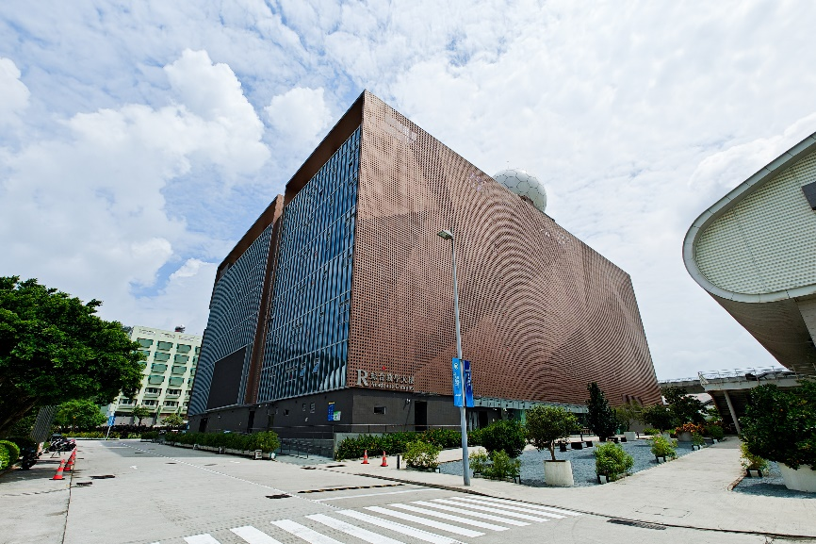
Figure 1. Block R of the MUST.
Another crucial aspect for ensuring the success of the project experience initiative is the selection of buildings where students will conduct the certification. In certification practices, the size and complexity of buildings typically correlate with the efforts required for certification, leading to higher costs and resource allocation for MUST's participation in this project experience initiative. However, due to the social responsibility mission associated with this initiative, BSL has allowed MUST to choose any building for certification without imposing additional costs for selecting a larger or more complex structure. While there are no cost implications for choosing which building to participate in the certification, MUST has taken a prudent approach to selecting a building for the project experience initiative, ensuring that the project experinece initiative balances the interests of stakeholders, especially in terms of avoiding any additional workload that could potentially disrupt students' academic studies. To identify the appropriate building, BSL and MUST conducted a walking tour of buildings across the campus and held an initial meeting with professional assessors from BSL, faculty from the campus sustainability committee and the campus facility management team to identify suitable buildings for the project experience initiative. Ultimately, Block R, as shown Figure 1 was selected for the project experience initiative. The choice of Block R stemmed from the fact that it was originally designed with green principles in mind, constructed in 2019 in accordance with the "Assessment Standard for Green Building (Macau Version)," utilizes a whole life-cycle approach [11] and has good connectivity with neighbourhood amenities, as depicted in Figure 2. As a result, students should be able to develop a credit strategy that ensures successful certification without requiring extensive, time-consuming, and costly retrofitting work by the campus facility management team. Additionally, the certification process must be completed within one (1) year to ensure that all required work for the certification is finished by the selected cohort and does not carry over to other cohorts. Therefore, selecting a building that is not prepared for certification could delay the program and hinder students participation. Block R does not have that constraint, as it already incorporates some degree of green elements in its design and operation.

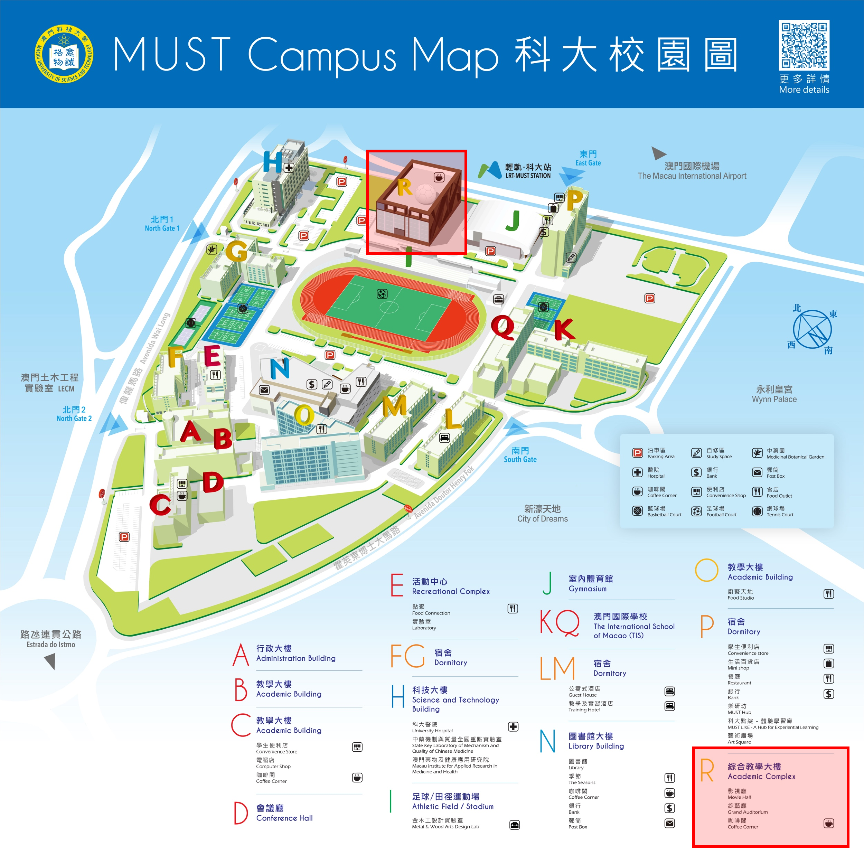
Figure 2. MUST Campus Map with the location of Block R highlighted.
4. Certification Preparation
Once the participants and buildings for the project experience initiative have been identified, the initiative moves into the stakeholder engagement and certification preparation phase. This phase is organized into several timeboxes [12] to ensure consistent progress and facilitate the timely completion of the initiative within one year. Three (3) timeboxes have been established at this stage: (a) training on the fundamentals, (b) credit alignment with the project and (c) submittal preparation and technical assessment. Each timebox is designed to reflect the typical operations of a genuine green building certification project. In contrast to traditional certification preparation processes that mainly involve engineers, facility managers, and green building consultants—while often excluding professional assessors due to conflicts of interest—this initiative also enlists students and professional assessors in the process. This inclusive approach promotes direct interaction and feedback, expediting the certification preparation process and enabling timely adjustments to the technical criteria to better align with the project's context.
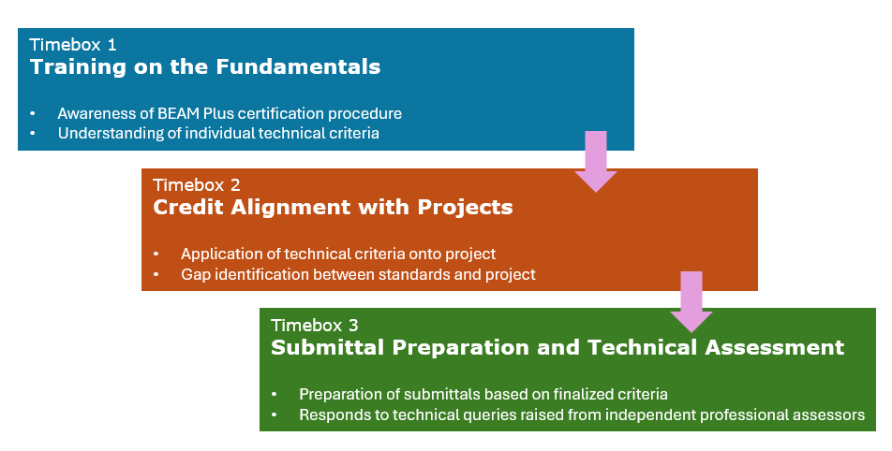
Figure 3. The timeboxes applied in the certification preparation process.
4.1 Training on the Fundamentals
Two half-day workshops were conducted for the students—one focused on the fundamentals of the BEAM Plus assessment tool, specifically the BEAM Plus Existing Buildings (Global Version), which the project intends to adopt, while the other provided background on Block R. In the first workshop, professional assessors delivered training on the technical requirements of the BEAM Plus Existing Buildings (Global Version) and the certification process. They highlighted that the tool is appropriate for buildings in operation and/or minor retrofit and the assessment tool encompasses eight (8) aspects: Management, Integrated Design and Construction Management, Sustainable Site, Materials and Waste, Energy Use, Water Use, Health and Well-being, and Innovation. These aspects provide a comprehensive benchmark for assessing Block R's green performance and enable it to benchmark against generalized baseline standards, including those from both international and regional best practices [13]. Students learned about the general credit criteria and the techniques necessary for earning credits during certification. They were given a credit summary as a takeaway to assist in their pre-assessment of the project against the BEAM Plus Existing Buildings (Global Version). After this workshop, the students divided the workload among themselves, with each student taking responsibility for two (2) of the eight (8) assessment aspects.
In the second workshop, the campus facility manager introduced the background of Block R, covering the overall green building management framework, the building services systems in place and the green features already integrated into Block R. Utilizing the credit summary they received earlier, students engaged proactively with the campus facility management to understand the challenges the buildings face in obtaining credits from the BEAM Plus Existing Buildings (Global Version). They also discussed how certain credits might not accurately reflect Block R's performance and the potential need for further negotiations with BSL for credit interpretation before preparing the submission package for the assessments.
4.2 Credit Alignment with Project
Following the two workshops, the students compiled a checklist of information needed from the campus facility manager, which included energy consumption data, water usage data, air quality testing results, building equipment performance data and maintenance records, as these contribute significantly to the credits. The students also conducted a site walk to verify compliance with sustainable site requirements. Using the gathered data, the group performed a preliminary assessment of Block R against the BEAM Plus Existing Buildings (Global Version) criteria. The initial score indicates that the project is on the borderline for a Gold Rating. However, both the faculty from the campus sustainability committee and the campus facility manager established a client requirement that the building must achieve a Platinum Rating. Key gaps identified for reaching Platinum were in the Ozone Depleting Substance and Energy Benchmarking Improvement credits. The students subsequently collaborated with the campus facility manager and his consultants to investigate the underlying reasons for these shortfalls.
The investigation identified a fundamental misalignment: the building is a recently constructed (within five years) educational facility designed to a high green standard, whereas the BEAM Plus criteria is calibrated for typical existing buildings with a commercial function. Consequently, the standard requirements for the Ozone Depleting Substance and Energy Benchmarking Improvement credits were not fully applicable. Specific technical mismatches included applying a Global Warming Potential threshold of 50 to all air conditioning equipment [14] and a 30% annual energy reduction target based on green financing benchmarks, such as the Hong Kong Taxonomy for Sustainable Finance [15].
In response, the students, in consultation with the campus facility manager, filed a formal Credit Interpretation Request (CIR) with the BSL for review. This process prompted the BSL to issue an addendum, updating the criteria to better reflect the circumstances of modern, sustainably designed educational buildings. The revisions included a higher Global Warming Potential threshold of 800 for window, unitary, split, and packaged air-conditioners and a new scoring tier for annual energy reduction based on the Energy Utilization Index results from a credible benchmarking tool, the Energy Star Portfolio Manager. This adjustment allowed the students to proceed with preparing the project's certification documentation against more appropriate technical benchmarks. Although this procedural review took approximately two months, it provided a valuable learning experience. The students gained practical insight into negotiating with a certification body by applying scientific rationale and adhering to standard procedures. They also played a role in demonstrating and enhancing the flexibility of the BEAM Plus Existing Buildings (Global Version) system, proving the tool’s resilience in adapting to local contexts within an international framework.
4.3 Submittals Preparation and Technical Assessment
Once the technical criteria were aligned, the students began preparing their submissions for certification. First, they conducted a final crosscheck of the current operating conditions of the buildings against the technical criteria of the BEAM Plus Existing Buildings (Global Version) to ensure that the design and management framework included the necessary elements to earn certification credits. Next, with assistance from the campus facility manager, they developed management policies, reports, and drawings that met the required standards for credits. Some students went above and beyond by creating a BIM model to highlight the sustainability features of Block R to secure innovation credits, as illustrated in Figure 4. Finally, those responsible for health and well-being credits utilized appropriate testing equipment to assess the buildings' indoor environments, supported by faculty from the sustainability committee and campus facility managers. Once all deliverables were completed, the students conducted peer reviews of each other's work before presenting their submissions to the campus facility manager and faculty from the sustainability committee for endorsement and approval for submitting their works for technical assessment by BSL. Throughout this process, the students learned to prepare and conduct peer reviews professionally to ensure they would qualify for certification credits, as well as the techniques to present to clients to seek approval for their advisory works.

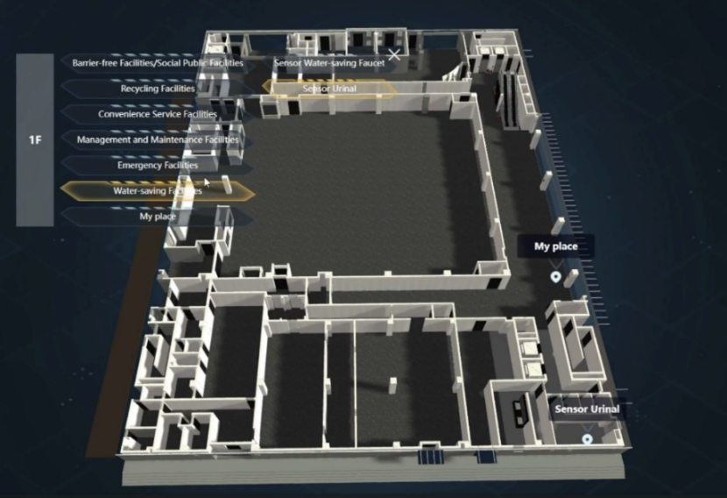
Figure 4. Student-developed BIM model showcasing the sustainability features of
Block R and was submitted as part of the innovation credits.

The project then progressed to the technical assessment stage, where an independent professional assessor from BSL reviewed the deliverables and provided comments for the applicants to address and justify their claims. Despite the tremendous effort the students put into preparing their submissions for certification, they received over ten (10) pages of feedback requesting clarifications on the technical aspects of their deliverables. After reviewing the comments with their peers, faculty from the sustainability committee and the campus facility manager, the students recognized further misalignment between the BEAM Plus Existing Buildings (Global Version) and Macau's green building operation ecosystem, particularly in defining the qualified personnel for indoor air quality testing—a system that has not yet been formalized in Macau. As a result, the students negotiated with BSL for an interpretation that would align the credit criteria with local conditions before formally responding to the technical queries raised by the independent assessor and submitting the finalized documentation to complete the certification process.
In summary, while the BEAM Plus certification procedures allows for only one formal revision after the technical review [16], the students proactively revised their deliverables multiple times during the preparation and response phases. This was driven by concerns that the initial submissions might encounter issues during the final review or reveal previously overlooked misalignments between the credit criteria and the project. Such oversights could have led to contested credits and a failure to achieve the target Platinum Rating as per the client’s requirements. Although these additional revisions increased their workload, the students adopted a meticulous approach to ensure all the deliverables fully complied with certification requirements. This experience ultimately instilled in the students a strong sense of accountability and responsibility for meeting client expectations, which is essential for earning the client’s trust in a professional working environment in the green building industry.
5. Certification and Discussion
After more than a year of aligning technical requirements, preparing submissions, and undergoing technical review, the project achieved certification in October 2025. Block R earned most of the expected credits and was awarded a Platinum rating, confirming its success as a high-performance green building. A certificate award ceremony was held around the same time to recognize the achievement, including presenting the BEAM Plus certificate to MUST faculty and celebrating the participating students’ accomplishments. Students received certificates of achievement for their outstanding involvement in Block R’s BEAM Plus certification, strengthening their resumes for future job searches.
Although the certification timeline took about one year, students also invested extra effort beyond their coursework to participate in the project experience program. Many reported gaining practical understanding of the green building certification process, which helped support their career development. Importantly, one student secured a job offer by discussing his participation with a prospective employer, suggesting that employers value these programs because they reduce the time and resources needed to train new hires.
The pilot has generated momentum for wider rollout. A Memorandum of Understanding was signed between MUST, BSL, and the Hong Kong Green Building Council to explore extending the programme to other cohorts and projects. All stakeholders are eager to scale the initiative, and a post-completion assessment identified key factors to support sustainability and improve the programme’s future scalability. First, the programme’s success depends on strong backing from campus facility managers, consultants, faculty from the sustainability committee, and BSL assessors. Without their involvement, students may find it difficult to interpret requirements and respond effectively to technical review questions. Second, many technical components, such as building performance data and indoor air quality test reports, often rely on professional inputs. Some of this information may be sensitive, which can make facility managers reluctant to share it. As a result, future iterations should provide clear and reliable support so students can compile complete submission packages. Third, because the programme adds to students’ workload, future iterations should consider managing workload impacts and potentially recruiting participants from other majors to broaden benefits and reduce overcommitment. In summary, replicating the programme’s success will require sustained resources and active commitment from all stakeholders.
6. Conclusion
The pilot project involving students actively managing the BEAM Plus certification for MUST Block R offered a unique opportunity to enhance their skills for the professional environment, complementing the existing academic curriculum. This model can serve as a reference for other universities aiming to provide learning opportunities that prepare students for careers in the green building industry, aligning with SDG 4 and promoting sustainable, inclusive communities under SDG 11. However, the program's success hinges on active participation from various stakeholders, a clear division of responsibilities and participants' resilience in adapting to the changing project environment and industry practices. Given their limited industry experience, students participating in the project experience program rely heavily on support from standard setters and assessors at BSL, as well as campus facility management professionals and faculty from the sustainability committee, to help them resolve technical challenges and collect the necessary data for certification. Such technical support is crucial to the success of future project experience initiatives and to ensuring the sustainability of the initiative. The stakeholders involved are optimistic that this case will inspire universities to partner with green building standard setters and assessors to create more innovative learning experiences, enhancing students' readiness for careers in the green building sector and sustaining a high-quality workforce in the industry.
References
[1] Guo HL, Li Heng & Skitmore M. Life-cycle management of construction projects based on virtual prototyping technology. Journal of Management in Engineering. 2010 26(1) pp 41-47
[2] Pandit A. The Impact Of Value Engineering On Pre-Construction Cost Control: Striking The Balance Between Quality And Budget. International Scientific Journal of Engineering and Management. 2023 02(11):1-8
[3] Osfio EO, Omumu ES & Alozie M. Evolving contractual obligations in construction law: Implications of regulatory changes on project delivery. World Journal of Advanced Research and Reviews. 2025 25(03), 1315-1333
[4] United Nations Department of Economic and Social Affairs. Goal 4. 2025. Retrieved from: https://sdgs.un.org/goals/goal4
[5] United Nations Department of Economic and Social Affairs. Goal 11. 2025. Retrieved from: https://sdgs.un.org/goals/goal11
[6] Project Management Institute. 2017. A guide to the project management body of knowledge. Project Management Institute, Pennsylvania, PA
[7] Zwikael, O. 2009 The relative importance of the PMBOK® guide's nine knowledge areas during project planning. Project Management Journal, 40(4). 94–103.
[8] Walker, R.L., Florea, L. Easy-Come-Easy-Go: Moral Hazard in the Context of Return to Education. J Bus Ethics 120, 201–217 (2014). Retrieved from: https://doi.org/10.1007/s10551-013-1656-8
[9] US Green Building Council. LEED V5. 2025. Retrieved from: https://www.usgbc.org/leed/v5
[10] HKSAR Electrical and Mechanical Services Department. Regulatory Regime for Buildings Energy Efficiency. 2022. Retrieved from: https://www.emsd.gov.hk/filemanager/en/content_1490/Rgltry_Regime_Leaflet_BEEO.pdf
[11] Macau University of Science and Technology. Research on SDG 11 – Sustainable Cities and Communities. 2025. Retrieved from: https://sust.must.edu.mo/page/SDG11.html?locale=en_US
[12] Agile Alliance. What is Timebox. 2025. Retrieved from: https://agilealliance.org/glossary/timebox/
[13] Hong Kong Green Building Council. BEAM Plus Existing Buildings Global Version. 2025. Retrieved from: https://www.hkgbc.org.hk/eng/beam-plus/beam-plus-existing-buildings-global/index.jsp
[14] BEAM Society. BEAM Plus Existing Buildings (Global Version) Version 1.0. 2024. Retrieved from: https://www.beamsociety.org.hk/en/BEAM-Plus/-/media/A3A4107075214B8DB977C3DBD2DB0651.ashx
[15] Hong Kong Monetary Authority. Hong Kong Taxonomy for Sustainable Finance. 2024. Retrieved from: https://brdr.hkma.gov.hk/eng/doc-ldg/docId/getPdf/20240503-3-EN/20240503-3-EN.pdf
[16] BEAM Society. BEAM Plus Procedures Manual (Assessment) Version 8.0. 2025. Retrieved from: https://www.beamsociety.org.hk/BEAM-Plus/Assessment-Fee-and-Procedure/-/media/535EEA7455D046C6B513EBB816D097A1.ashx

