BIM-Based Framework for Sustainable Building Constructions: Combining Holistic Sustainability Attributes with Integrated EPD and End-of-Life Data
Shervin Rahnama^{1*}, Carla Klein¹, Nina Middendorf², Niels Bartels³, Sebastian Theißen⁴, Sven Mackenbach¹ and Katharina Klemt-Albert¹
¹ Chair and Institute of Construction Management, Digital Engineering and Robotics in Construction, RWTH Aachen University, Aachen, Germany
² Institute of Building Services Engineering, TH Koeln – University of Applied Sciences, Cologne, Germany
³ Faculty of Civil Engineering and Environmental Technology, TH Koeln – University of Applied Sciences, Cologne, Germany
⁴ Dept of Digital Design, Construction and Operation, University of Wuppertal, Wuppertal, Germany

*E-mail: rahnama@icom.rwth-aachen.de

Abstract. Although Building Information Modeling (BIM) is increasingly used in construction, the integration of sustainability indicators remains limited. Current practices often focus solely on environmental indicators, neglecting economic and social aspects. Moreover, integrated data is frequently structured in a way that limits reusability for automation, resulting in BIM models overloaded with unstructured information.
This paper presents a BIM-based framework for embedding holistic sustainability attributes into digital building models using wall constructions as a representative element. Relevant indicators were derived from the German sustainability assessment system BNK/BNG. A mixed-methods approach was applied in which 16 expert interviews as well as a workshop with 4 LCA experts were analyzed using Mayring’s qualitative content analysis to examine modeling practices, sustainability information needs and identify improvement potentials. A prototype digital model was then developed and validated using representative masonry wall constructions.
Results indicate that material choices primarily affect thermal transmittance, sound insulation, production costs, Global Warming Potential (GWP), non-renewable primary energy use (PENRT), and End-of-Life (EoL) recyclability. EoL scenarios were subdivided into categories considering connections, accessibility, and deconstruction potential. Hybrid modeling approaches proved most suitable for enabling automation while preserving planners’ workflows.
The validation process shows that the proposed approach enables the structured enrichment of information with consistent terminology. This paves the way for automated sustainability assessments and further optimization. However, existing data gaps, particularly with regard to end-of-life data, can significantly distort results. This highlights the need for consistent, holistic sustainability datasets and appropriate attribute modelling in the early design stages.

1. Introduction
The construction industry generates a massive amount of waste, e.g. the construction industry in Germany accounts for 54% of national waste generation, 90% of mineral raw material consumption and 40% of CO₂ emissions [1]. Currently, the entire German building stock is to be made climate-neutral by 2045 at the latest [2]. This requires a profound transformation towards a planning and construction approach that integrates holistic sustainability throughout the entire building life cycle.
In this context, sustainability assessments have so far predominantly focused on the environmental dimension, while economic, sociocultural, and functional aspects are often disregarded. [3] This one-dimensional approach hinders holistic sustainability assessments, which are increasingly required by certification systems [4]. In construction practice, the environmental dimension is predominantly assessed using life cycle assessments (LCA), which are still largely conducted manually and at late planning stages, despite the fact that key sustainability decisions are made during the early design phases. A promising approach is the early integration of sustainability assessments into model-based planning processes using Building Information Modeling (BIM). [5–7].
In its current form, LCA according to EN 15978 reaches its methodological limits when it comes to adequately reflecting circular properties [8]. While LCA provides structured environmental information at the product and material level, it largely ignores component-specific characteristics such as joining, installation situation, or separability [9]. Moreover, End-of-Life scenarios are often applied uniformly based on established recycling methods, without considering material interdependencies, layer structures, or the accessibility of connections [10]. As a result, existing reuse options may be overlooked or overestimated. [9] A methodologically consistent link between LCA and circularity assessment at the component level is not possible based on current assessment approaches. This not only makes it difficult to perform a feasible LCA but also prevents the early consideration of deconstruction options and recycling paths in the planning process.
There is also a lack of suitable digital workflows that systematically record relevant parameters and integrate them into the sustainability assessment. Although BIM models enable the structured modeling of components and materials, the necessary information has not yet been standardized or made systematically evaluable, which hinders automated evaluation [10, 11]. Therefore, a precise definition of information requirements is essential for efficient linking and processing of relevant sustainability information [3]. Researchers have investigated BIM-based sustainability assessments in various academic texts. Wastiels and Decuypere propose a classification scheme with five approaches for implementing sustainability information into BIM models [12]. These include object-based approaches with enriched BIM objects [12, 13], server-based concepts such as BIM2LCA4IP enabling IFC-based bidirectional data exchange [5], and semantically enriched IFC schemas, for example within the buildingSMART International Information Delivery Manual (IDM) “openBIM & Sustainability” [3, 5, 11, 14, 15]. While bidirectional linking allows automated updates of LCA results based on model changes, practical application remains limited due to insufficient and inconsistent data availability [16].
Recent studies further show that BIM-based workflows can support LCA in early design stages but remain strongly constrained by data availability and model quality. Forth et al. demonstrate the feasibility of openBIM-based LCA workflows, while highlighting the need for simplified assumptions in early phases [17]. To address these limitations, Guntermann et al. emphasize the definition and automated verification of information requirements in IFC models using Information Delivery Specifications (IDS) as a prerequisite for reliable digital sustainability assessments [18].

2. Methodological Approach
Given the challenges of sustainability assessments described above, this study contributes to promoting sustainable planning by creating a basis that enables automated assessments based on comprehensive sustainability information in digital building models. The aim of this paper is to develop a framework for embedding holistic sustainability attributes into digital building models. The objective is to identify relevant attributes for sustainability assessment and to determine how they can be structured within the model and made usable.
To achieve this goal, the paper addresses the following research question: How can relevant sustainability attributes be structured and embedded in digital building models to enable their use in automated sustainability assessments?
To address the research question, this study first identifies relevant sustainability indicators and examines their implementation within a digital building model. The proposed implementation methods are then validated using a residential building case study. Finally, the findings are discussed, and limitations and future research directions are presented.
The relevant indicators for a holistic sustainability assessment are identified based on an existing certification system. To reduce complexity, this paper initially focuses on multi-layered exterior walls, which account for around 25% of a seven-storey residential building's GWP [19]. This focus serves as the basis for validation. The approach is similarly transferable to other building components.
Next, commonly used modeling methods are derived from the literature and compared with practical approaches using interviews. To obtain practical approaches, a mixed-methods methodology is applied. The distinction between LCA experts and BIM authors follows prior research on BIM-based LCA, which identifies a structural gap between stakeholders who use sustainability information and those responsible for creating the corresponding BIM data [20]. Accordingly, a two-perspective approach is adopted: LCA experts provide requirements for sustainability assessments, while BIM authors contribute current modeling practices and practical constraints. The sample size was determined based on theoretical saturation. All participants provided informed consent, and all data was anonymized.
A workshop with four LCA experts was conducted to identify the required geometric and semantic information for BIM-based sustainability assessments. The central research question was: What are the geometric and semantic requirements for multi-layer masonry structures for model-based holistic sustainability assessments? A group discussion format was chosen to stimulate reflection. The participants included two R&D employees with a focus on BIM-based LCA at a general contractor, one BIM and sustainability consultant in public administration, and one BIM project manager with extensive experience in BIM-based LCA. The workshop took place in January 2025, was transcribed, and analyzed using QCAmap following Mayring’s qualitative content analysis with inductive category development [21]. To complement the requirements perspective, sixteen open, problem-centered interviews with BIM authors were conducted between January and March 2025. The interviewees represent common authoring environments: 13 use Autodesk Revit, one Graphisoft Archicad, and two both systems. The interviews addressed current workflows for geometric and semantic modeling of multi-layered exterior walls as well as challenges in integrating sustainability information. The data was analyzed in QCAmap using inductive category development according to Mayring. To enhance reliability, an intra-coder agreement was performed by re-coding a subset of the data after a time interval and assessing consistency [21–23]. Finally, the findings from the literature review and the expert interviews are validated through practical tests using Autodesk Revit and Graphisoft Archicad [20, 22].

3. Results
  - Relevant indicators for a holistic sustainability assessment
To obtain the relevant indicators for a holistic sustainability assessment, there are several certification systems that address environmental, economic, and sociocultural qualities. [7]. Many of these indicators are defined quantitatively, allowing for a measurable evaluation and comparison of projects. One example is the German BNK/BNG certification for residential buildings. This certification provides a practical, structured framework that is widely used in Germany. It includes the three sustainability dimensions, as well as technical and functional requirements, in accordance with EN 15643. [23] The approach considers environmental life-cycle impacts in accordance with EN 15978. Economic aspects cover life-cycle costs and value retention. Socio-cultural aspects relate to user health, comfort, and social needs. Functional quality reflects technical performance, while process quality includes planning- and execution-related factors influencing long-term sustainability, such as information for dismantling, separation, and recycling. [8, 24] The BNK/BNG indicators and their allocation to the different sustainability dimensions are illustrated in Figure 1. Other systems, such as BREEAM and LEED, also rely on quantitative, indicator-based categories, which makes this approach transferable across certification systems.
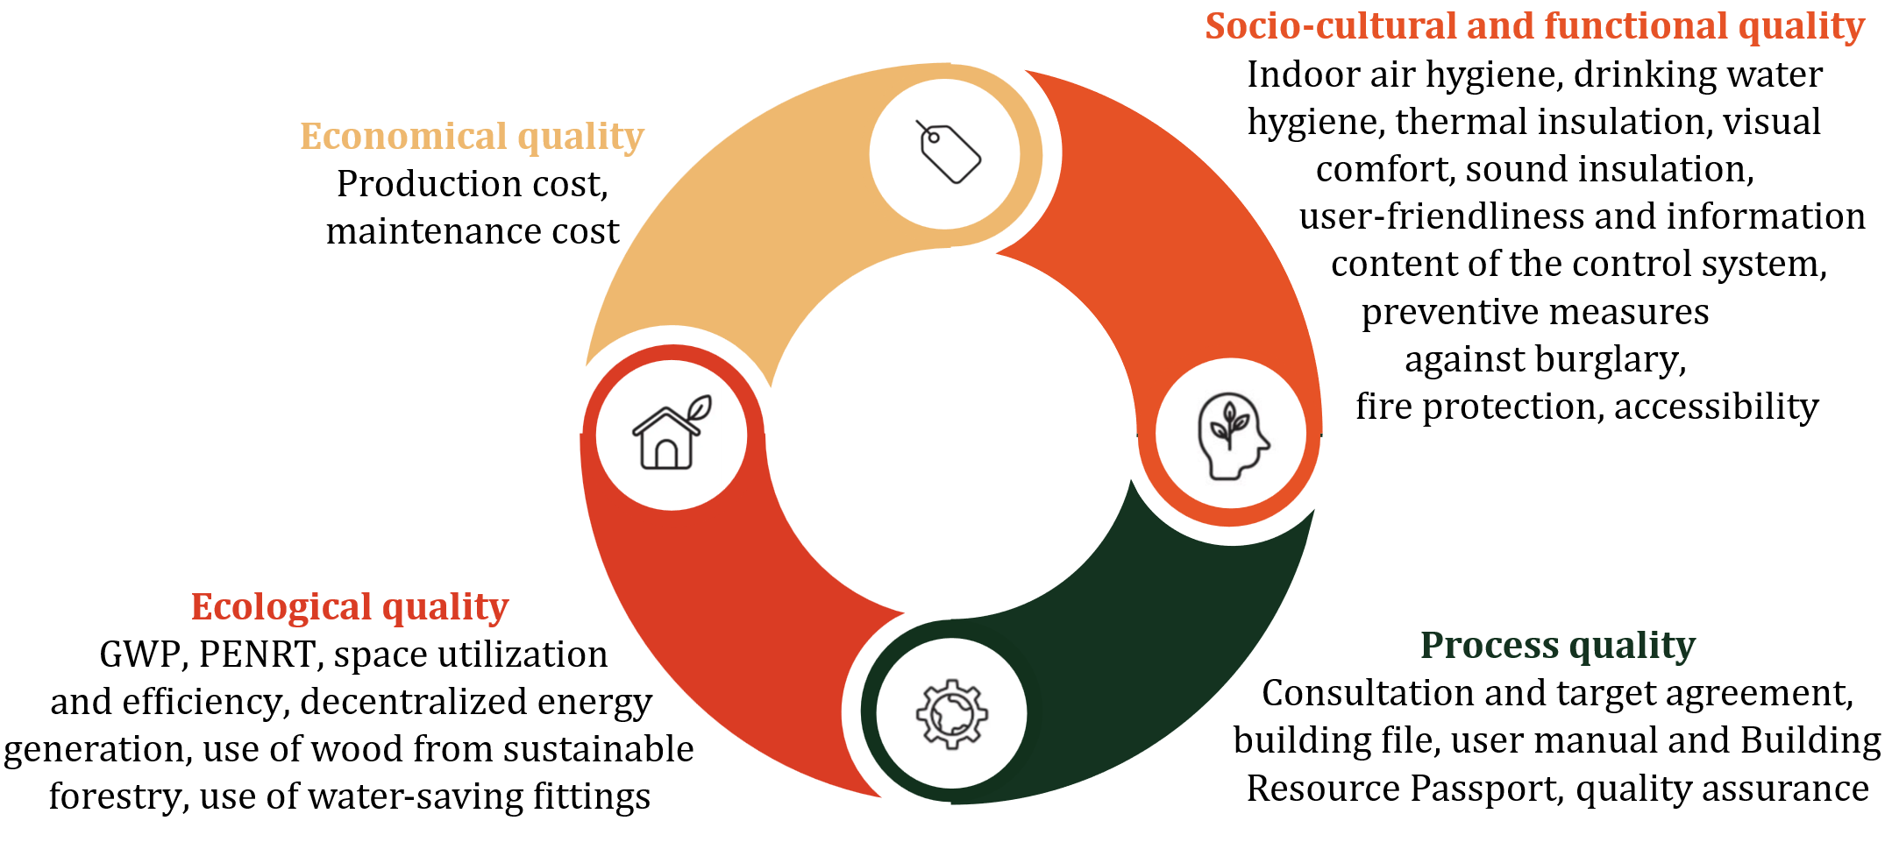
Figure 1. BNK/BNG indicators across sustainability dimensions (Authors' own work, based on [25])
To apply the holistic sustainability framework at the wall component level, the BNK/BNG catalogue was systematically screened to identify all indicators that are directly or indirectly influenced by the design and material configuration of exterior wall constructions. Based on this analysis, a set of key indicators is presented in the following as the result of this reduction process.
GWP & PENRT: Quantification of GWP and PENRT associated with material production, replacement, operation, and EoL processes over a 50-year assessment period. The assessment is based on EN 15804+A2-compliant Environmental Product Declarations (EPDs), including modules A1–A3, B4, B6, C3, and C4, in accordance with EN 15978. [8, 26]
Cost (Production & maintenance): A net present value approach over 50 years, covering production and maintenance phases.
Thermal insulation: Standardized calculation methods or thermal simulation based on material and construction properties.
Sound insulation: Weighted sound reduction index Rw according to German standards, considering both material properties and construction configuration.
Fire protection: On a construction level fire resistance is assessed in accordance with EN 1996-1-2 [27], based on material behavior.
Circularity: Circularity was identified as a key sustainability indicator, as EoL scenarios in current assessment approaches are often simplified and insufficiently reflect construction-specific conditions. While LCA is widely used to quantify environmental impacts, it primarily operates at the material level and does not account for dependencies between materials within building components. In methodologies such as BNK/BNG and Quality Seal for Sustainable Buildings (QNG), dismantling and recyclability are assessed using simplified indicators and generic datasets, leading to assumptions on service lives and replacement cycles that neglect actual connection types, accessibility, and dismantling feasibility [28, 29]. These limitations highlight the need to further develop LCA towards a component-based perspective that integrates circular properties such as joinability, accessibility, and dismantlability in order to derive more feasible EoL pathways.
To address this limitation, a EoL-framework is introduced in this study that differentiates EoL scenarios based on constructive conditions. The framework does not replace the conventional LCA but extends it by incorporating construction-related information in order to restrict EoL assumptions to scenarios that are technically feasible under the given conditions.
Within the standard EN 15978 [8], EoL processes are represented by the modules C and D, which cover dismantling, waste treatment, disposal, and potential benefits beyond the system boundary through reuse, recycling, or energy recovery. The required data is provided through EN 15804-compliant Environmental Product Declarations (EPDs) [26]. Figure 2 illustrates the conceptual integration of circularity-related information into the LCA framework according to EN 15978 [8]. The figure situates the proposed approach within the established life cycle structure (modules A–D) and highlights how decisions made during the production and construction stages (A1–A5), such as the selection of connection techniques and the resulting accessibility of individual layers, influence dismantling processes (C1), waste treatment (C3), and disposal pathways (C4). These construction-specific conditions determine whether materials can be separated without damage and recovered as distinct material streams, thereby constraining the feasible EoL scenarios and the associated substitution effects accounted for in module D.
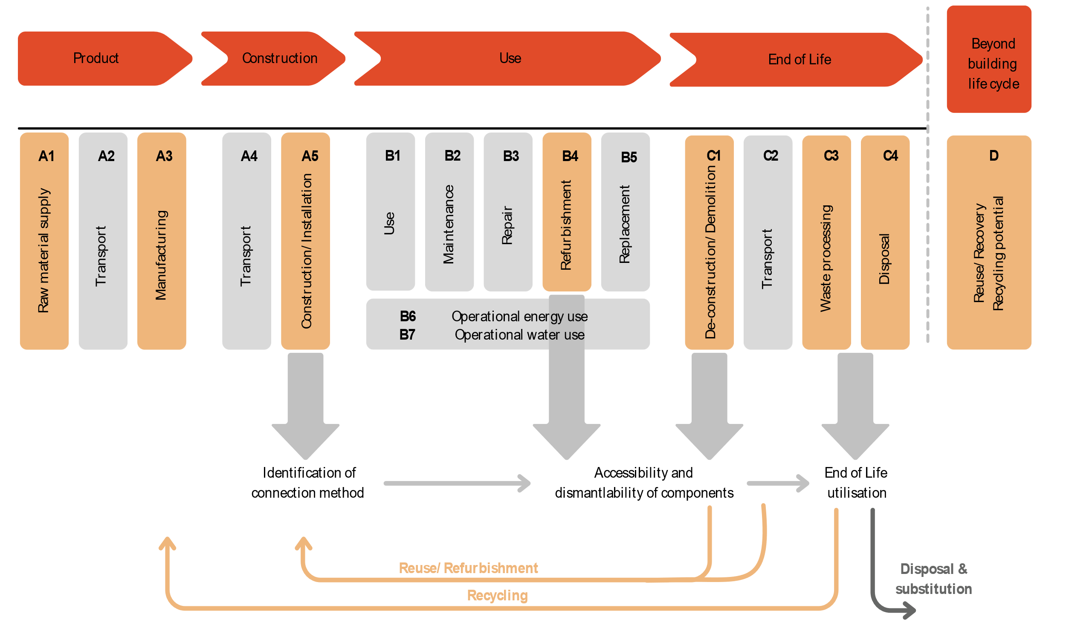
Figure 2. Conceptual integration of circularity information into the LCA framework according to EN 15978 (authors’ own work based on [8])
To properly account for reuse, refurbishment, or recycling, it is necessary to consider specific aspects of the construction and its raw condition. However, information that can only be obtained through an external product inspection is excluded. Therefore, the focus is on information inherently available within the digital model rather than subsequent external factors. These aspects are derived from international and national standards, specifically the EU Construction and Demolition Waste Management Protocol on the EU level and DIN SPEC 91484 in Germany. The key aspects of a feasible EoL framework are listed below.
Connection types: the classification of connection types between layers to assess dismantling effort and technical separability, based on typical connection categories as applied in the DGNB Circularity Index and by Ebert et al. [30, 31].
Layer accessibility: the assessment of layer accessibility following the detachability approach used by Madaster [32], considering whether layers can be accessed directly or only after dismantling preceding layers.
Theoretical EoL potentials: the determination of the technically possible EoL potential of each material in its uninstalled state using WECOBIS database and the material recovery categories defined in the DGNB Circularity Index [30].
Interchangeability: the derivation of layer interchangeability during the building’s service life by combining information on accessibility and service life, ensuring that replacement cycles are only applied where layers can be feasibly dismantled.

Finally, Figure 3 provides an example of the holistic sustainability assessment for the previously described key indicators.
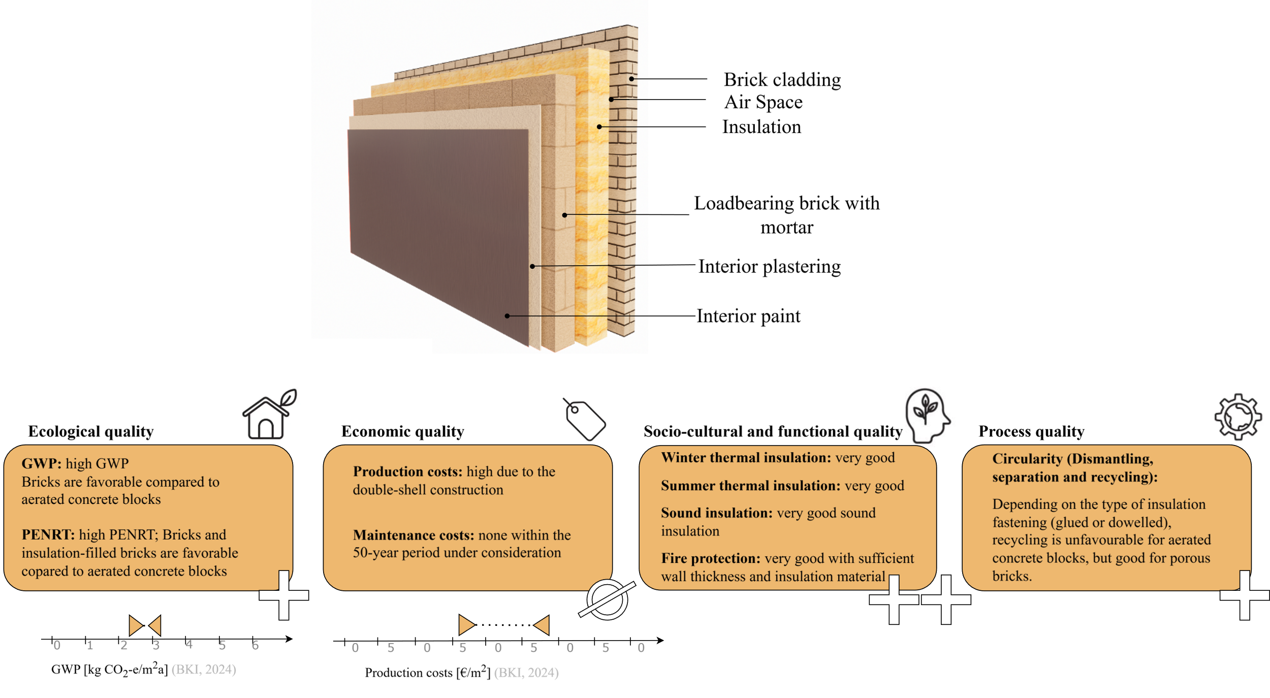
Figure 3. Example of a holistic sustainability assessment for a double-shell wall with core insulation (authors’ own work; data sources: based on [33–42])
  - BIM based Integration of Sustainability Indicators
After defining key sustainability indicators, this section examines their integration into BIM models at the geometric and semantic level. Building on the classification proposed by Patyna et al. and Helmus et al., three modeling strategies for multi-layered wall constructions can be distinguished: single layer, hybrid, and multi-layer modeling (visualized in Figure 4) [43, 44].
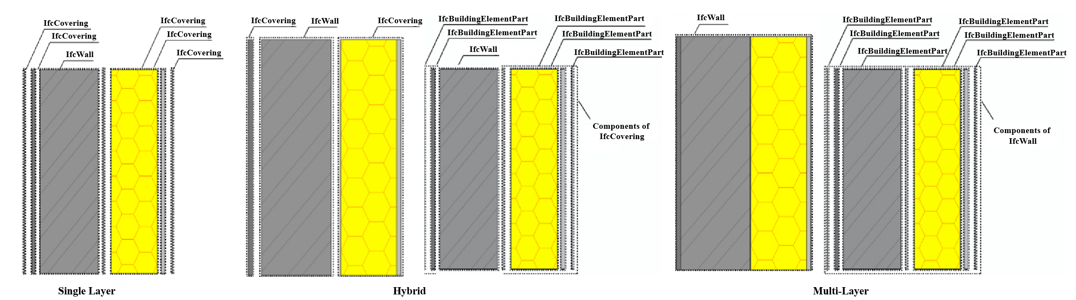
Figure 4. Modeling methods for multi-layered walls (Authors' own work, based on [43, 44])
In single-layer modeling, all layers are modelled as separate walls directly adjacent to each other. The utilization of hybrid modeling facilitates the distinction between shell and finishing elements. Loadbearing elements are modelled individually, while finishing elements are modelled in multi-layer packages. In the multi-layer modeling method, the entire wall structure is modeled as a package. As illustrated in the figure above, when additional layers are included in the corresponding packages, they must be exported as IfcBuildingElementPart entities to access the information in the respective layers.
The following section summarizes the findings on suitable modeling strategies and contrasts them with the insights from the interviews. Practical tests were also conducted to validate the interview findings. These tests involved implementing modeling approaches in two authoring tools and exporting models to assess the given use case's functionality. To ensure traceability of findings, results are explicitly attributed to their source: literature (LIT), interviews (INT), workshop (WOR) and practical tests (PRA).
The reviewed literature recommends avoiding multi-layer modeling using IfcBuildingElementPart. The main reason is the difficulty of assigning IFC entities and mapping the elements to classification systems such as OmniClass [43, 45] (LIT). Another limitation identified by the interviewed BIM authors regarding multi-layer walls is the modeling of entire wall constructions as a single package. Technical drawings require a clear distinction between load-bearing and non-load-bearing elements (INT).
Given the challenges of distinguishing between load-bearing and non-load-bearing elements, hybrid modeling approaches appear to be a valuable solution. In several practical tests, layer-specific properties could be assigned to load-bearing elements while maintaining the IFC classification, which allows the information to be extracted correctly (PRA). However, not all issues can be resolved. The modelling of finishing layers as packages (IfcBuildingElementPart) leads to previously identified limitations, particularly with respect to the assignment of appropriate IFC entities and the mapping of elements to classification systems (LIT+PRA). According to the interviewed BIM authors, the hybrid approach is widely used in practice (INT).
Besides multi-layer modeling, the literature suggests that single-layer modeling is the more recommended approach [44](LIT). The LCA experts who use BIM as a basis for sustainability assessments confirmed this preference (WOR). They favored single-layer modelling due to its clear classification possibilities (WOR). However, the expert interviews with the BIM authors, who create the BIM models, describe this approach as time-consuming and reported challenges in representing connections between layers (INT). These limitations are also confirmed through practical tests (PRA). The literature confirms that single-layer modeling limits the ability to derive information about connections between directly connected layers from IFC models [46, 47] (LIT).
Overall, the results suggest that both practice and literature, as well as the tests conducted in this paper, indicate that the suitability of modeling strategies depends on both the information requirements and capabilities of the authoring tools. In light of the findings, this paper adopts a hybrid modeling strategy using IfcBuildingElementPart, which provides a practical approach for capturing information on load-bearing and non-load-bearing layers, as well as sustainability information. The following Table 1 illustrates how the identified sustainability indicators can be implemented within a digital building model. In addition, a minimal set of information requirements is defined that must be provided within the authoring software. These requirements were selected because they form the basis from which additional sustainability-relevant information can be derived or calculated automatically. This lean modeling approach maximizes automation while minimizing manual input, reduces data redundancy, and supports a centralized single source of truth [48]. The principle of minimal attribution was explicitly emphasized by LCA experts during the workshop as essential for avoiding unnecessary data generation.

Table 1. Information requirements based on [7, 8, 15, 45, 49–56]
Category | Information | Min. | Pset | Property | Qset | Quantity
General | IFC Entity | ✓ | - | Ifc*Type | - | -
 | PredefinedType | ✓ | - | Ifc*Type.PredefinedType | - | -
 | Name of the construction | ✓ | ePset | Name of the construction | - | -
 | Layer material | ✓ | - | IfcMaterialLayer.Material | - | -
 | Layer Thickness | ✓ | - | IfcMaterialLayer.Layer | - | -
 |  |  |  | Thickness | - | -
 | Layer area (net) | ✓ | - | - | Qto_*Base | NetSide
 |  |  |  |  | Quantities | Area
 | Layer volume | ✓ | - | - | Qto_*Base | NetVolume
 |  |  |  |  | Quantities | NetVolume
 | External | ✓ | Pset_*Common | IsExternal | - | -
 | Loadbearing | ✓ | Pset_*Common | LoadBearing | - | -
 | Classification | - | ePset | Assembly code | - | -
 | Life span | - | Pset_EnvironmentalImpactIndicators | ExpectedServiceLife | - | -
 | Unit | - | Pset_EnvironmentalImpactIndicators | Unit | - | -
 | Reference of functional unit | - | Pset_EnvironmentalImpactIndicators | FunctionalUnitReference | - | -
Thermal
 | Thermal Transmittance | - | Pset_*Common | ThermalTransmittance | - | -
 | Thermal conductivity | ✓ | Pset_MaterialThermal | ThermalConductivity | - | -
 | Density | ✓ | Pset_MaterialCommon | MassDensity | - | -
Sound-proofing
 | Weighted sound reducting index | - | ePset | WeightedSoundReducting  index | - | -
Fire protection
 | Building material class | - | ePset | BuildingMaterialClass | - | -
Cost
 | Manufacturing costs | - | ePset | ManufacturingCosts | - | -
 | Maintenance and inspection costs | - | ePset | MaintenanceAnd InspectionCosts | - | -
 | irregular maintenance costs | - | ePset | IrregularMaintenance Costs | - | -
GWP /PENRT
 | GWP/PENRT A1-3 | - | ePset | GWP/PENRT_A1-3 | - | -
 | GWP/PENRT B4 | - | ePset | GWP/PENRT_B4 | - | -
 | GWP/PENRT C3 | - | ePset | GWP/PENRT_C3 | - | -
 | GWP/PENRT C4 | - | ePset | GWP/PENRT_C4 | - | -
 | GWP/PENRT D1 | - | ePset | GWP/PENRT_D1 | - | -
Circularity
 | Connection method | ✓ | ePset | ConnectionMethod | - | -
 | Layer sequence | - | ePset | LayerSequence | - | -
The possibilities for the semantic integration of the holistic sustainability indicators depends on the semantic capabilities of the IFC schema. Currently, there is a lack of IFC properties that are considered suitable for many sustainability indicators. Furthermore, the nomenclature of the respective IFC properties also varies widely, often due to company-specific conventions overriding standardization. In addition, responsibility for attribute assignment is highly fragmented, as was confirmed by the BIM authors. To assess the applicability of the proposed hybrid modeling and information requirements, the following section validates these findings.

4. Validation
This section presents the validation of the proposed BIM-based integration approach with regard to technical consistency and practical applicability. Rather than focusing on the accuracy of individual values, the validation assesses whether the modeling strategy and information requirements enable structured information enrichment with consistent terminology. This serves as a basis for subsequent automated sustainability assessments and optimization. The approach is applied to representative wall constructions with hybrid modeling strategy to evaluate the retrievability of sustainability-relevant information, including the IFC export and the applicability of the circularity framework.
The architectural model of a residential bungalow prototype is developed through the utilization of the Autodesk Revit and Graphisoft Archicad software applications. A total of four masonry wall constructions are selected as an initial case study due to their widespread use in practice. The previously introduced minimal information requirements (Table 1) are defined within the authoring tool. Except for the ConnectionMethod, these requirements can be implemented in both Autodesk Revit and Graphisoft Archicad. However, when using Autodesk Revit, post-export information enrichment is required, as layer-level properties such as the ConnectionMethod cannot be directly assigned to IfcBuildingElementPart. This enrichment is carried out in Thinkproject VDC Manager. The validation further revealed software-specific differences in IFC export behavior that affect the implementation of these requirements. While Archicad provides complete quantity and material distribution information for layered elements (e.g., insulation layer width via Qto_CoveringBaseQuantities and material shares via the Fraction property of IfcConstituentSet), Revit shows limitations in exporting such data. As a result, required information cannot be consistently derived from the IFC model without additional processing, indicating that feasibility depends on both the modeling approach and the IFC export capabilities of the authoring tool. [43, 44]. Errors in information transfer are often caused by limitations or inconsistencies in IFC export implementations [57]. Consequently, it is not possible to provide universally applicable, vendor-neutral modeling recommendations, as each approach has its own advantages and limitations.

- Creation of the digital building model
  - Revit: Creation of geometry and enrichment with minimal attributes (see Table 1, excluding ConnectionMethod)
  - Archicad: Creation of geometry and enrichment with minimal attributes (see Table 1, including ConnectionMethod)
- IFC Export
- Information Enrichment
  - Revit: Adding connections methods via Desite
  - Archicad: No additional steps
- IFC model verification via IDS

To validate the completeness and consistency of the information requirements (Table 1), a buildingSMART Information Delivery Specification (IDS) is used to define information requirements in a machine-interpretable form. The IDS enables automated compliance checking of IFC models, thereby improving data quality and reliability. It is developed to verify the presence, data types, units, and permissible value ranges of all information requirements (Table 1).
The validation confirms that the required sustainability-related properties are successfully implemented, exported, and machine-readably retrievable across both authoring tools.
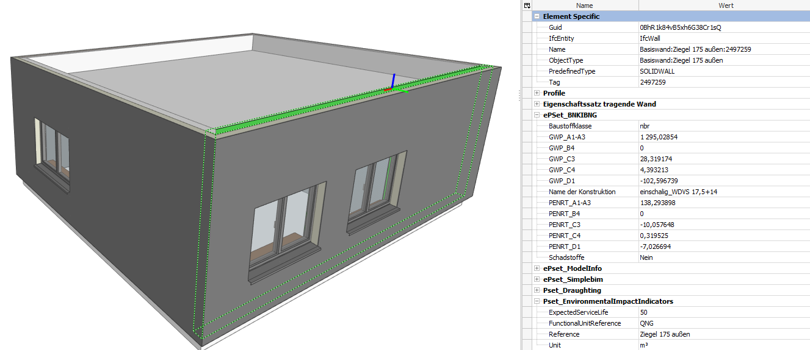
Figure 5. Validation of geometric and semantic information (screenshot)
Based on the geometrically and semantically validated BIM model, the proposed circularity assessment framework is applied to evaluate its methodological consistency and practical applicability. The semantic, material-related, and layer-structured information already present in the model enable a systematic assessment of constructive conditions at component level, allowing the circularity framework to be executed as intended.
The validation confirms that the methodological logic of the framework is internally consistent and operational when the required model-based information is available in the validated BIM model. Information retrieved from the BIM model enables the classification of connection types, accessibility, and the position of individual layers within the overall assembly, from which construction-specific and feasible EoL scenarios can be derived. The environmental impacts associated with these scenarios are subsequently quantified using data from EPDs.
For masonry wall constructions, the validation reveals that the applicability of the framework is primarily constrained by the limited availability and low level of differentiation of EoL information in existing datasets rather than by methodological limitations of the approach itself. While constructive differentiation and qualitative scenario derivation can be performed, the quantitative implementation of circularity scenarios remains restricted. To further evaluate the framework, additional wall types are considered where more detailed EoL information is available in existing EPDs, for example timber wall constructions.

5. Discussion & Conclusion
This study examines how relevant sustainability attributes can be structured and embedded in digital building models to enable their use in automated sustainability assessments. It proposes a BIM-based framework that embeds holistic sustainability indicators at geometric and semantic levels, focusing on multi-layer wall constructions and environmental, economic, socio-cultural, functional, and circular aspects.
The IFC-based integration of properties considering GWP, PENRT, cost, sound and thermal performance, and circularity proved technically feasible. These attributes can be consistently structured within BIM models to enable automated evaluation, provided suitable datasets are available. From an automation perspective, the information must either be taken into account in the digital model or supplemented externally. Regardless of the chosen approach, a basic sustainability assessment can already be enabled using minimal datasets.
Based on the literature, the circularity indicator emerged as particularly relevant. To operationalize this indicator, a circularity framework differentiates EoL pathways and identifies high-quality reuse and recycling potential based on the construction. However, the results show that circularity assessments strongly depend on data availability. Although the current version of EN 15804 requires scenario-based declarations across modules A to C, most available environmental product declarations do not yet provide this level of differentiation, as these normative requirements are relatively recent and are only limitedly reflected in existing EPDs. Consequently, materials with theoretically superior EoL performance may receive unfavorable ratings due to the limited data available. Also, standard C3/C4 scenarios often assume thermal recycling by default, ignoring higher circular potential. This highlights the need for more granular datasets to enable comprehensive circularity evaluation across diverse construction systems. Comparable data gaps were identified for economic and functional indicators, including costs, sound and thermal insulation, and fire protection. This supports findings in the literature that sustainability assessments predominantly focus on environmental aspects, while other dimensions are often neglected. This can be explained by the generally defined sustainability goals.
The utilization of a comprehensive set of sustainability indicators, while addressing modeling effort, necessitates the consistent provision of a minimal set of defined information requirements for said indicators. These information requirements can be automatically checked using an IDS, which reduces the effort required for LCA experts to perform sustainability assessments. Depending on the scope of the model-based sustainability assessment, additional data such as cost and soundproofing information can be integrated into the model during later design or execution planning stages. For example, this can be achieved by integrating external databases across all sustainability dimensions. Consequently, there are multiple implementation methods, and the chosen approach should be defined at the beginning of each project.

6. Limitations & Future work
As demonstrated in the paper, the automated performance of sustainability assessments is associated with challenges in data enrichment of IFC models and correct, software-specific IFC export. Either the data should be available directly in the model or it should be possible to link it to other data using the information in the model.
Integrating the data into the model increases the modeling effort. One possible solution is to standardize properties and use uniform material catalogs. However, the current IFC schema does not adequately represent holistic sustainability information. To enable consistent Open BIM-based assessments, further standardization at the IFC level would therefore be necessary. However, this would involve increased implementation effort and limited flexibility.
Using minimum data from the model and connecting with external data results in availability of external data. Specifically, given the focus on Germany, there is a significant lack of freely accessible external databases that provide comprehensive, standardized, and up-to-date data suitable for integration into BIM-based sustainability assessments. For a holistic sustainability assessment, a uniform database should be developed for material-related data. Relevant information could then be efficiently linked to digital building models from a central data source. However, developing such a database would present new challenges, particularly with regard to clearly assigning materials to the appropriate data sets. Automated approaches using AI-based methods to link materials to the corresponding data are required to meet these challenges. These approaches are a key step in transitioning from manual to automated assessment.
There are still gaps in the reuse EPD data for various materials, necessitating an expansion of the corresponding datasets. Regarding the EoL framework and its subcategories, this study focused primarily on the feasible perspective. For a realistic EoL framework, external factors, including the condition of the products, must be considered. In addition, potential sales markets for secondary distribution should be analyzed, even though they largely determine the potential for reintegrating materials and products. Therefore, future work should systematically consider both the feasibility and the realism of EoL.

References
[1] A. Hillebrandt, D. A. Schwede, and J. Stretzeder, Transformation zu einer zirkulären Bauwirtschaft als Beitrag zu einer nachhaltigen Entwicklung: Position der kommission nachhaltiges bauen am umweltbundesamt (KNBAU). [Online]. Available: https://​www.umweltbundesamt.de​/​sites/​default/​files/​medien/​479/​publikationen/​knbau_​transformation_​zu_​einer_​zirkulaeren_​bauwirtschaft.pdf (accessed: Dec. 5 2025).
[2] S. Oehler, "Die Stadt der Zukunft," in Emissionsfreie Gebäude, S. Oehler, Ed., Wiesbaden: Springer Fachmedien Wiesbaden, 2023, pp. 1–67.
[3] C. LLatas, B. Soust-Verdaguer, A. Hollberg, E. Palumbo, and R. Quiñones, "BIM-based LCSA application in early design stages using IFC," Automation in Construction, vol. 138, p. 104259, 2022, doi: 10.1016/j.autcon.2022.104259.
[4] E. Tsirovasilis, M. Katafygiotou, and C. Psathiti, "Comparative Assessment of LEED, BREEAM, and WELL: Advancing Sustainable Built Environments," Energies, vol. 18, no. 16, p. 4322, 2025, doi: 10.3390/en18164322.
[5] S. Ebertshäuser et al., BIM-basierte Integrale Planung: Gemeinsamer Schlussbericht. [Online]. Available: https://​www.blm.ieb.kit.edu​/​downloads/​BIM2LCA4IP_​Schlussbericht.pdf (accessed: 28.12.24 12:35 Uhr).
[6] F. Prideaux, K. Allacker, R. H Crawford, and A. Stephan, "Integrating life cycle assessment into the building design process—a review," Environ. Res.: Infrastruct. Sustain., vol. 4, no. 2, p. 22001, 2024, doi: 10.1088/2634-4505%2Fad3577.
[7] N. Bartels, J. Höper, S. Theißen, and R. Wimmer, Application of the BIM Method in Sustainable Construction: Status Quo of Potential Applications in Practice, 1st ed. Cham: Springer International Publishing AG, 2023. [Online]. Available: https://​link.springer.com​/​content/​pdf/​10.1007/​978-​3-​031-​12759-​5.pdf
[8] CEN, EN 15978 Sustainability assessment of construction works – assessment of environmental performance of buildings – calculation method.
[9] H. Abu-Ghaida, M. Ritzen, A. Hollberg, S. Theissen, S. Attia, and S. Lizin, "Accounting for product recovery potential in building life cycle assessments: a disassembly network-based approach," The International Journal of Life Cycle Assessment, vol. 29, no. 7, pp. 1151–1176, 2024, doi: 10.1007/s11367-024-02324-8.
[10] K. Forth, J. Abualdenien, and A. Borrmann, "Calculation of embodied GHG emissions in early building design stages using BIM and NLP-based semantic model healing," Energy and Buildings, vol. 284, p. 112837, 2023, doi: 10.1016/j.enbuild.2023.112837.
[11] B. Soust-Verdaguer, I. Bernardino Galeana, C. Llatas, M. V. Montes, E. Hoxha, and A. Passer, "How to conduct consistent environmental, economic, and social assessment during the building design process. A BIM-based Life Cycle Sustainability Assessment method," Journal of Building Engineering, vol. 45, p. 103516, 2022, doi: 10.1016/j.jobe.2021.103516.
[12] L. Wastiels and R. Decuypere, "Identification and comparison of LCA-BIM integration strategies," IOP Conf. Ser.: Earth Environ. Sci., vol. 323, no. 1, p. 12101, 2019, doi: 10.1088/1755-1315/323/1/012101.
[13] L. Á. Antón and J. Díaz, "Integration of Life Cycle Assessment in a BIM Environment," Procedia Engineering, vol. 85, pp. 26–32, 2014, doi: 10.1016/J.PROENG.2014.10.525.
[14] J. Gantner et al., "Ökobilanz – Integration in den Entwurfsprozess," Bauphysik, vol. 40, no. 5, pp. 286–297, 2018, doi: 10.1002/bapi.201800016.
[15] M. Bekboliev et al., openBIM & Sustainability: Unveiling Challenges, Crafting Solutions for a Sustainable Built Asset Industry: Information Delivery Manual. [Online]. Available: https://​ucm.buildingsmart.org​/​use-​case-​details/​3324/​en (accessed: 04.02.25 19:23 Uhr).
[16] C. Boje et al., "A framework using BIM and digital twins in facilitating LCSA for buildings," Journal of Building Engineering, vol. 76, p. 107232, 2023, doi: 10.1016/j.jobe.2023.107232.
[17] K. Forth, A. Hollberg, and A. Borrmann, "BIM4EarlyLCA: An interactive visualization approach for early design support based on uncertain LCA results using open BIM," Developments in the Built Environment, vol. 16, 2023, doi: 10.1016/j.dibe.2023.100263.
[18] L. Guntermann, P. Hagedorn, and M. König, "Enhancing IFC Models for Circular Design: Validation of Required Information through an IDS Framework,"
[19] E. Pischetsrieder, "Planungsbegleitende Ökobilanzierung in der Praxis," in BKI Konstruktionsatlas KA1: Bauteile mit Ökobilanzen, CO2-Äquivalenten und Baupreisen für die nachhaltige und wirtschaftliche Planung, BKI Baukosteninformationszentrum, Ed., Stuttgart: RM Rudolf Müller Medien, 2023, pp. 44–55.
[20] R. K. Zimmermann, S. Bruhn, and H. Birgisdóttir, "BIM-Based Life Cycle Assessment of Buildings—An Investigation of Industry Practice and Needs," Sustainability, vol. 13, no. 10, p. 5455, 2021, doi: 10.3390/su13105455.
[21] P. Mayring, Einführung in die qualitative Sozialforschung: Eine Anleitung zu qualitativem Denken, 7th ed. Weinheim, Basel: Beltz, 2023. [Online]. Available: https://​www.content-select.com​/​index.php​?​id=​bib_view&​ean=​9783407296023
[22] L. Waas and Enjellina, "Review of BIM-Based Software in Architectural Design: Graphisoft Archicad VS Autodesk Revit," JARINA, vol. 1, no. 2, pp. 14–22, 2022, doi: 10.24002/jarina.v1i2.6016.
[23] CEN, EN 15643 Sustainability of construction works – EN 15643 Framework for assessment of buildings and civil engineering worksof buildings – calculation method.
[24] H.-D. Hegner and N. Kerz, "Nachhaltiges Bauen in Deutschland — Bewertungsystem des Bundes für Büro‐ und Verwaltungsbauten," Mauerwerk, vol. 14, no. 4, pp. 195–207, 2010, doi: 10.1002/dama.201002050.
[25] BiRN, BNKIBNG (QNG) Kriteriensteckbriefe. [Online]. Available: https://​bau-irn.com​/​bnkibng-​system/​bnkibng-​qng-​kriteriensteckbriefe (accessed: 28.12.24 22:02 Uhr).
[26] CEN, 15804+A2 Sustainability of construction works – Environmental product declarations – Core rules for the product category of construction products.
[27] CEN, EN 1996-1-2: Design of masonry structures - Part 1-2: General rules - Structural fire design.
[28] S. Rahnama, E. Heinlein, and Y. Youraoui, "Analyse der literaturbasierten Nachhaltigkeitsindikatoren im Wohnungsbau mit den Indikatoren von BNK|BNG (QNG)," in Tagungsband 34. BBB Assistent*innen-Tagung 2025 Berlin, pp. 137–149.
[29] C. Krinitzki, L. Hotten, and C. Hartz, "Zur Kreislauffähigkeit von Deckenkonstruktionen," Bautechnik, vol. 102, no. 9, pp. 523–533, 2025, doi: 10.1002/bate.70012.
[30] A. Braune and I. V. Wellstein, "DGNB QUALITÄTSSTANDARD FÜR ZIRKULARITÄTSINDIZES FÜR BAUWERKE," 2024. [Online]. Available: https://​www.tab.de​/​download/​2093831/​DGNB-​Qualitaetsstandard-​fuer-​Zirkularitaetsindizes-​fuer-​Bauwerke.pdf
[31] S. Ebert, S. Ott, K. Krause, A. Hafner, and M. Krechel, "Modell der Recyclingfähigkeit auf Bauteilebene," Bautechnik, vol. 97, S1, pp. 14–25, 2020, doi: 10.1002/bate.201900109.
[32] Madaster Deutschland, BIM-Handbuch: Für Revit und Archicad. [Online]. Available: https://​docs.madaster.com​/​files/​de/​madaster%20GER_​BIM%20Anleitung.pdf
[33] BKI Baukosteninformationszentrum, Ed., BKI Konstruktionsatlas KA1: Bauteile mit Ökobilanzen, CO2-Äquivalenten und Baupreisen für die nachhaltige und wirtschaftliche Planung. Stuttgart: RM Rudolf Müller Medien, 2023.
[34] BKI Baukosteninformationszentrum, Ed., BKI Konstruktionsatlas KA2: Bauteile mit Ökobilanzen, CO2-Äquivalenten und Baupreisen für die nachhaltige und wirtschaftliche Planung. Stuttgart: BKI, 2024.
[35] N. Diefenbach, B. Stein, T. Loga, M. Rodenfels, and K. Jahn, Monitoring der KfW-Programme „Energieeffizient Sanieren“und „Energieeffizient Bauen“ 2016. [Online]. Available: https://​www.kfw.de​/​PDF/​Download-​Center/​Konzernthemen/​Research/​PDF-​Dokumente-​alle-​Evaluationen/​Monitoringbericht_​EBS_​2016.pdf (accessed: 11.01.25 10:54 Uhr).
[36] T. Loga, B. Stein, N. Diefenbach, and R. Born, Deutsche Wohngebäudetypologie: Beispielhafte Maßnahmen zur Verbesserung der Energieeffizienz von typischen Wohngebäuden. [Online]. Available: https://​www.episcope.eu​/​downloads/​public/​docs/​brochure/​DE_​TABULA_​TypologyBrochure_​IWU.pdf (accessed: 09.01.25 16:09 Uhr).
[37] Ł. Mazur, O. Szlachetka, K. Jeleniewicz, and M. Piotrowski, "External Wall Systems in Passive House Standard: Material, Thermal and Environmental LCA Analysis," Buildings, vol. 14, no. 3, p. 742, 2024, doi: 10.3390/buildings14030742.
[38] T. Loga, B. Stein, N. Diefenbach, and R. Born, Deutsche Wohngebäudetypologie: Beispielhafte Maßnahmen zur Verbesserung der Energieeffizienz von typischen Wohngebäuden. [Online]. Available: https://​www.episcope.eu​/​downloads/​public/​docs/​brochure/​DE_​TABULA_​TypologyBrochure_​IWU.pdf (accessed: 09.01.25 16:09 Uhr).
[39] H. Gscheidle and J. Röder, "Außenwände," in Lehrbuch der Hochbaukonstruktionen, N. A. Fouad, Ed., Wiesbaden: Springer Fachmedien Wiesbaden, 2013, pp. 541–763.
[40] M. Schäfers, Konstruktive Umsetzung verschiedener Schallschutzniveaus im Massivbau. [Online]. Available: https://​pub.dega-akustik.de​/​DAGA_​2017/​data/​articles/​000438.pdfhttps://​pub.dega-​akustik.de/​DAGA_​2017/​data/​articles/​000438.pdf (accessed: 13.01.25 8:43 Uhr).
[41] A. Tersluisen et al., Untersuchung zeitgemäßer, monolithischer Wandaufbauten hinsichtlich bauphysikalischer, ökologischer und ökonomischer Eigenschaften. [Online]. Available: https://​www.irbnet.de​/​daten/​rswb/​18059020119.pdf (accessed: 07.02.25 11:35 Uhr).
[42] H. König, Projekt: Lebenszyklusanalyse von Wohngebäuden: Lebenszyklusanalyse mit Berechnung der Ökobilanz und Lebenszykluskosten. [Online]. Available: https://​www.lbb-bayern.de​/​fileadmin/​quicklinks/​Quick-​Link-​Nr-​98300000-​LfU-​Gesamtstudie_​Lebenszyklusanalyse.pdf (accessed: 12.01.25 11:00 Uhr).
[43] M. Patyna, B. Franke, and S. Schlecht, Leitfaden zur IFC-basierten Erstellung von Ökobilanzen für Gebäude: EnOB/BMWi: MobiDik - Entwicklung einer Mobilen und Digitalen Lernfabrik für das Handwerk 4.0 Teilvorhaben: Erforschung und Entwicklung einer phasenübergreifenden, ganzheitlichen Gebäudebilanzierung (Förderkennzeichen: 03EN1016E). [Online]. Available: https://​www.tib.eu​/​de/​suchen/​id/​TIBKAT:​1892165929/​Verbundvorhaben-​EnOB-​MobiDiK-​Entwicklung-​einer​?​cHash=​85d451ead3492048e49f8a689a4719f5 (accessed: 05.12.12025).
[44] M. Helmus et al., Entwicklung einer standardisierten BIM-Modellierungsrichtlinie. [Online]. Available: https://​www.teamproject.de​/​wp-​content/​uploads/​2024/​05/​bbsr-​online-​43-​2023_​Entwicklung_​standardisierteBIM-​Modellierungsrichtlinie.pdf (accessed: 12.02.25 09:09 Uhr).
[45] M. Lambertz, S. Theißen, J. Höper, A. Hollberg, P. Hollberg, and H. König, Intuitive Kommunikation und Visualisierung von Gebäudeökobilanzen und Risikostoffen zur Entscheidungsunterstützung im digitalen Planungsprozess: Abschlussbericht über o.g. Forschungsvorhaben gefördert unter dem AZ: 36041 / 01 von der Deutschen Bundesstiftung Umwelt. [Online]. Available: https://​opac.dbu.de​/​ab/​DBU-​Abschlussbericht-​AZ-​36041_​01-​Hauptbericht.pdf (accessed: 21.12.24 13:05 Uhr).
[46] M. Honic, "Process-Design for the semi-automated generation of BIM-based Material Passports for buildings," Doctoral Thesis, Faculty of Civil Engineering, TU Wien, Wien, 2019. [Online]. Available: https://​repositum.tuwien.at​/​bitstream/​20.500.12708/​3257/​2/​Honic%20Meliha%20-​%202019%20-​%20Process-​design%20for%20the%20semi-​automated%20generation%20of…pdf
[47] O. Gbenga John, K. Forth, S. Theißen, and A. Borrmann, "Estimating the Circularity of Building Elements using Building Information Modelling," IOP Conf. Ser.: Earth Environ. Sci., vol. 1363, no. 1, p. 12043, 2024, doi: 10.1088/1755-1315/1363/1/012043.
[48] C. Preidel, A. Borrmann, H. Exner, and M. König, "Common Data Environment," in VDI-Buch, Building Information Modeling, A. Borrmann, M. König, C. Koch, and J. Beetz, Eds., Wiesbaden: Springer Fachmedien Wiesbaden, 2021, pp. 335–351.
[49] S. Bahlau et al., Digital Twin Footprint: Erarbeitung eines ganzheitlichen Meilensteinplans mit Handlungsempfehlungen und notwendigen Forschungsbausteinen zur zielführenden Verknüpfung der Lebenszyklusanalyse (Gebäudeökobilanzierung) und BIM-Planungsprozesse mit einem Fokus auf den frühen Planungsphasen. [Online]. Available: https://​www.bbsr.bund.de​/​BBSR/​DE/​veroeffentlichungen/​bbsr-​online/​2024/​bbsr-​online-​70-​2024.html (accessed: Dec. 5 2025).
[50] C. O. I. Châteauvieux, "BIM-gestützter Planungsprozess zur Berechnung des Schallschutzes im Holzbau," Doktorarbeit, TUM School of Engineering and Design, Technische Universität München, München, 2023. Accessed: 18.01.25 13:48 Uhr. [Online]. Available: https://​mediatum.ub.tum.de​/​doc/​1718115/​1718115.pdf
[51] J. Cassandro, C. Mirarchi, and A. Pavan, "IFC-based Cost Estimation: Application to A Structural Model," in Proceedings of the 2024 European Conference on Computing in Construction, 2024.
[52] ISO, ISO 6946: Building components and building elements — Thermal resistance and thermal transmittance — Calculation methods.
[53] C. Morbitzer, P. von der Weide, and A. Schröter, "Simulationsbasierte Bewertung sommerlicher Bedingungen in Gebäuden," in Bauphysik Kalender 2015, N. A. Fouad, Ed.: Wiley, 2015, pp. 377–414.
[54] S. Wieder, M. Gratzl, and T. Reiter, "EINBINDUNG DER BAUPHYSIKALISCHEN FACHBEREICHE SCHALL-, FEUCHTE- UND BRANDSCHUTZ IN DEN BIM-PLANUNGSPROZESS," 2020.
[55] K. Bodenschlägel, F. Frischmann, A. Rabold, and C. Châteauvieux-Hellwig, BIM-gestützte Schallschutz-Planung. [Online]. Available: https://​pub.dega-akustik.de​/​DAGA_​2022/​data/​articles/​000303.pdf (accessed: 18.01.25 13:50 Uhr).
[56] VIB, Handlungsempfehlung Digitalisierung und Building Information Modeling für die Brandschutzplanung. [Online]. Available: https://​www.vib-brandschutz.de​/​fileadmin/​media/​dokumente/​23-​06-​Handlungsempfehlung-​Digitalisierung-​und-​BIM-​fuer-​die-​Brandschutzplanung-​V1.0.pdf (accessed: 15.02.25 11:34 Uhr).
[57] C. C. Eichler, C. Schranz, T. Krischmann, H. Urban, M. Hopferwieser, and S. Fischer, BIMcert Handbuch: Grundlagenwissen openBIM: Mironde-Verlag, 2024. Accessed: 23.09.24 13:15 Uhr. [Online]. Available: https://​repositum.tuwien.at​/​bitstream/​20.500.12708/​192612/​3/​Eichler-​2024-​BIMcert%20Handbuch%20Grundlagenwissen%20openBIM-​vor.pdf

