Designing for Diversity: Integrating rock-based habitat with ecohydraulic modelling to support native fish in regulated rivers

Christine Lauchlan Arrowsmith¹, Pearl Elgindy¹ and Peter Rose²
1 Streamology Pty Ltd, Melbourne, Victoria, Australia. Email: christine@streamology.com.au
2 North Central Catchment Management Authority, Huntly, Victoria, Australia

Key Points
- Environmental water delivery alone is insufficient to restore hydraulic diversity in straightened irrigation channels; physical habitat structures are essential for native fish recovery.
- A novel rock-based design framework, comprising four structure types including nesting culverts, was developed for flowing-water specialist fish in Upper Gunbower Creek.
- Rock structures created localised velocity shear zones adjacent to slackwater refugia without measurable upstream afflux, addressing a key barrier to community and regulatory acceptance.
- The integrated ecohydraulic design approach is transferable to other regulated systems where channel simplification has depleted native fish habitat.

Abstract
River regulation across south-eastern Australia has simplified channel morphology and altered seasonal flow regimes, reducing the hydraulic diversity required to support native fish across multiple life stages. Habitat requirements for spawning, juvenile development and refuge depend on a mosaic of lotic habitat, adjacent slackwater areas, and strong velocity gradients along channel margins (Tonkin et al., 2024). Previous two-dimensional (2D) hydraulic modelling demonstrated these habitats respond non-linearly to discharge: spawning habitat generally increases with flow; slackwater habitat declines until higher geomorphic features engage (Streamology, 2023).
In straightened irrigation channels, such as Upper Gunbower Creek, environmental water alone is insufficient to recreate this diversity, with new physical habitat required. Instream restoration typically prioritises large wood, but this project adopted a novel rock-based approach as field observations suggested that native fish congregate around rocky outcrops and that wood–rock structures often support higher fish diversity. We applied a 2D hydraulic model to quantify slackwater, spawning habitat and hydraulic diversity across flow scenarios. Modelling results informed the location and design of rock blanket and pyramid structures and nesting variants. The simulations showed intermediate discharges maximised hydraulic diversity. The rock structures created localised velocity shear zones adjacent to refuge areas without measurable upstream afflux. This transferable approach demonstrates how modelling-led, joint ecological–geomorphology disciplinary design can restore hydraulic diversity in regulated rivers

Keywords
instream habitat restoration; native fish; hydraulic diversity; 2D hydraulic modelling; Murray cod; rock habitat structures; regulated rivers; ecohydraulics

Introduction
River regulation across south-eastern Australia has profoundly altered aquatic ecosystems. Irrigation infrastructure, channel modification and altered flow regimes have collectively reduced the physical and hydraulic complexity upon which flowing-water specialist fish depend (Stuart et al., 2019). Upper Gunbower Creek is a clear example of this impact: the construction of the National Channel severed natural meanders, removing the structural heterogeneity that once characterised this system and leaving a simplified, largely unidirectional channel with limited instream habitat.
Flowing-water specialists including Murray cod (Maccullochella peelii), trout cod (M. macquariensis), golden perch (Macquaria ambigua), and Murray River crayfish (Euastacus armatus) depend on a mosaic of lotic, lentic and transitional hydraulic conditions throughout their life cycles. Spawning and early juvenile recruitment are strongly linked to lotic conditions, while slackwater refugia support juvenile survival during high-flow periods. Recovery of these habitat types in heavily regulated, straightened channels cannot be achieved through environmental water delivery alone.
This paper describes an integrated approach developed for North Central Catchment Management Authority (North Central CMA): a background review of hydraulic habitat requirements, 2D hydraulic modelling, and novel rock-based habitat structure design across a 6 km reach of Upper Gunbower Creek. Four structure types were developed, selected using ecohydraulic criteria, and evaluated for their hydraulic effects. The approach can be applied to other regulated systems where channel simplification has degraded native fish habitat.

Study Area
Gunbower Creek is an anabranch of the Murray River, located within the North Central Catchment Management Authority’s region of northern Victoria. The study reach is the first 6 km of Gunbower Creek, between Torrumbarry Weir Road and Headworks Road. The channel has been significantly modified through the development of the National Channel, an irrigation channel that replaced natural meanders with a straightened, trapezoidal cross-section and regulated connections to adjacent lagoons. The resulting channel has limited hydraulic diversity, reduced instream wood loads, and minimal geomorphic complexity.
Despite this modification, upper Gunbower Creek retains ecological value as a corridor for flowing-water specialist fish. Murray cod, trout cod, golden perch and Murray River crayfish have all been recorded in the system. The creek delivers environmental water from Torrumbarry Weir to downstream reaches of Gunbower Creek, with environmental flows managed under the Gunbower Creek System Environmental Water Management Plan (North Central CMA, 2015).

Hydraulic Habitat Requirements

A background review was undertaken to establish the hydraulic habitat criteria informing structure design and site selection.
Previous hydraulic modelling work combined with observations from the Tonkin et al. (2024) study had quantified physical habitat attributes used by early life stages of native fish and macrocrustaceans across the Goulburn and Campaspe rivers. Flowing-water specialists prefer a combination of lotic conditions (mean velocity >0.3 m/s; depth >0.4 m) and lentic refuge (velocity <0.01 m/s; depth <0.5 m), with hydraulic diversity defined as the co-occurrence of microhabitat velocities below 0.1 m/s and above 0.4 m/s within close proximity.
Stuart et al. (2019) demonstrated that provision of lotic habitat was a critical driver of Murray cod juvenile recruitment in lower Gunbower Creek, with environmental flows enabling recovery once lotic habitat extent increased. Murray cod spawn on hard substrates including rocks, clay ledges, and hollow logs - making rocky habitat directly relevant to breeding success.
While outside the Murray Darling Basin, monitoring by Glenelg Hopkins CMA has found that rock elements in fish habitat structures provide food-source complexity and predator protection, with greater diversity of fish sizes observed around structures that incorporate both rock and wood (S. Ryan, pers. comms.). Fish congregation near rock armour at regulating structures has also been noted (D. Iervasi, pers. comms.).
Based on this review, the following hydraulic parameters were adopted for site selection:
- Rock blankets: targeted at locations with velocity >0.3 m/s to introduce substrate roughness and turbulence, placed where velocities are below rock movement thresholds (v <2 m/s for 150 mm rock).
- Rock pyramids: targeted at slackwater areas (velocity <0.1 m/s) adjacent to faster flows (v >0.3 m/s) to enhance habitat diversity.
- Nesting culverts (within either structure type): positioned at water depths of 0.5–1.5 m, replicating natural cave and undercut habitats preferred by Murray cod and trout cod for spawning.

Hydraulic Modelling
A two-dimensional hydraulic model was developed using HEC-RAS across the 6 km study reach. The terrain incorporated a 2 m resolution bathymetric survey captured between 14–16 January 2026, supplemented by Upper Gunbower LiDAR supplied by North Central CMA. Sonar imaging was captured concurrently, enabling locations of existing woody debris to be tagged during post-processing. The model reproduced water levels with reasonable accuracy over the 6 km reach and was deemed fit for purpose to assess the relative impacts of introducing fish habitat structures.

Flow Scenarios
Flow scenarios ranging from 100 ML/d to 3,800 ML/d were simulated, representing the range of environmental flow types identified in the Gunbower Creek System Environmental Water Management Plan (North Central CMA, 2015). This included winter base flow (300 ML/d), spring-autumn base flow (400 ML/d), spring-summer modified fresh (600 ML/d), winter-spring high flow (1,200 ML/d) and channel capacity (3,800 ML/d), alongside intermediate values.

Structure Representation
The four proposed structure types were incorporated into the model using increased Manning’s roughness (n = 0.1 across an approximately 30 m length × 5 m width footprint) and, for rock pyramids, terrain increases of 1.5 m across 2 × 2 m cells in groupings of three to five pyramids per location.
Modelled maximum velocities across both existing and proposed scenarios were below 0.6 m/s, beneath the threshold for movement of alluvial and clay bed and bank material. This is also below the threshold to move the smallest specified rock (nominally 150 mm diameter).
Modelled impacts at key cross-sections were minor and localised: water level increases of less than 10 mm were observed, with velocity increases of up to 0.15 m/s confined to the instream portion of the channel with no increase in bank erosion potential.
The most ecologically significant hydraulic response was observed at intermediate flows around 1,200 ML/d, where structures generated the greatest increase in hydraulic diversity through expanded slow-velocity areas (v <0.1 m/s) adjacent to faster-flowing zones. Structures positioned on the downstream side of outer bends typically produced stronger diversity outcomes than those at straight reaches - an example is shown in Figure 1 below.
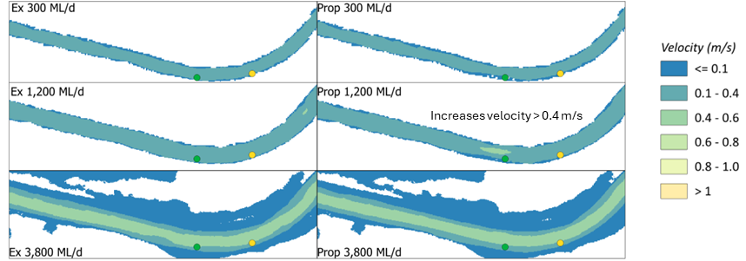
Figure 1. Hydraulic modelling results comparing depth and velocities between existing and proposed case. Increased diversity shown on downstream side of outside bend where a rock pyramid has been modelled (green dot).

Habitat Structure Design

Structure types
Four rock habitat structure types were designed to address the range of hydraulic conditions identified across the study reach:
- Rock blankets – irregular rock placed along cleared bank sections in faster-flowing areas to introduce substrate roughness and create micro-velocity gradients. Minimum extent of 3 m along bank; extendable to 30 m. Toe rocks (minimum 800 mm diameter) anchor the base.
- Rock blankets with nesting culvert – as above, incorporating a culvert (300–900 mm diameter; maximum 2 m length) as a simulated fish hollow. Culverts placed at 0.5–1.5 m depth, upstream end blocked, downstream opening reduced to 450–600 mm to replicate natural cavities.
- Rock pyramids – irregular rock structures (1.5–2 m base; 1.5 m height) placed in slackwater areas adjacent to faster flows, offset from the bank toe. Grouped in clusters of 3–6 per location.
- Rock pyramids with nesting culvert – as above, with a culvert embedded within the pyramid structure to provide spawning and refuge habitat for large-bodied cod species.
All structures were specified with angular, irregularly shaped quarry rock (D90/D10: 900/150 mm) to maximise interlocking stability and interstitial space. An example of the rock pyramid structure with nesting culvert concept design is shown in Figure 2.
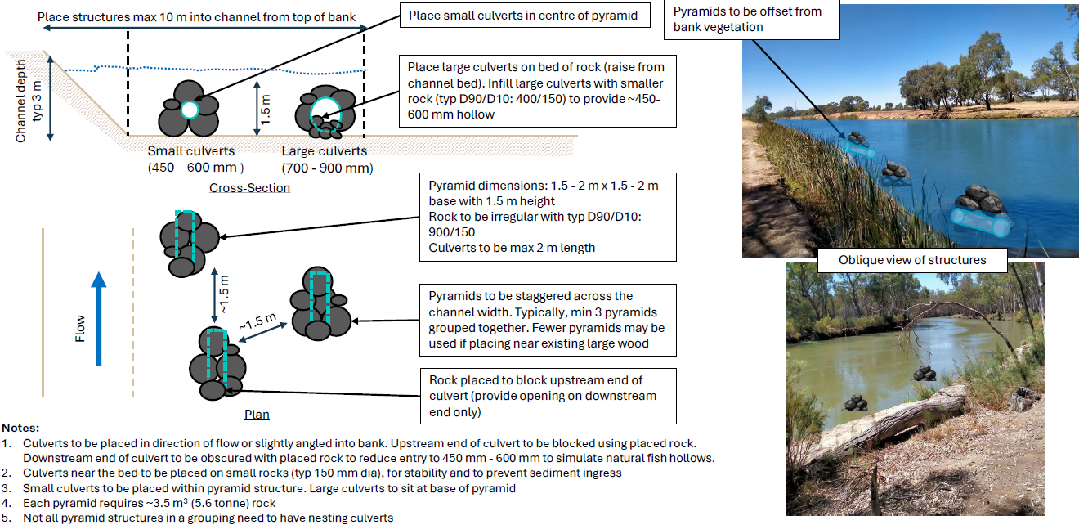
Figure 2. Concept design of rock pyramid structure with nesting culvert – showing plan view and typical section. Dashed lines indicate outline of nesting culverts situated beneath rock.

Site Selection
Using existing hydraulic modelling outputs and the ecological habitat criteria from the background review, a long list of candidate locations was identified across the 6 km study reach. This was refined through consultation with North Central CMA. Key refinements included removal of northern bank locations within the Welton Nature Conservation Reserve due to access constraints, and addition of two sites immediately downstream of Torrumbarry Weir Road bridge to link the upper reach to existing downstream habitat.
Fifteen structures were proposed across the study reach, comprising four rock blankets, five rock blankets with nesting culvert, three rock pyramids and three rock pyramids with nesting culvert. To support monitoring of ecological outcomes, the approximately 7 km reach downstream of Torrumbarry Weir Road bridge was designated as a control reach, with no structures proposed in that zone.

Discussion
This project provides a transferable framework for restoring hydraulic diversity in regulated rivers through ecohydraulic modelling and novel rock-based design. Two findings warrant broader consideration.
Rock as a habitat substrate is underutilised relative to large wood in Australian instream restoration practice. However, field observations suggest that rock structures support comparable or greater fish diversity in some contexts, particularly where they introduce velocity heterogeneity and provide nesting habitat that wood alone cannot replicate. The integration of culverts within rock structures mimics the cave and undercut habitats preferred by Murray cod and trout cod for spawning, a habitat type largely absent from modified channels where natural banks and woody debris have been removed.
The absence of measurable afflux under the proposed structure configurations is an important result for regulatory and community acceptance. Concerns about flooding impacts are a common barrier to instream restoration in irrigation systems. The modelling provides a defensible basis for proceeding with construction.

Conclusions
This study presents an integrated, modelling-led approach to rock-based instream habitat restoration in a regulated, straightened irrigation channel. Key findings and outcomes are:
- Four rock habitat structure types were designed, including novel rock blanket and pyramid variants incorporating nesting culverts to simulate natural fish hollows for Murray cod and trout cod spawning.
- Hydraulic modelling confirmed structures introduce localised velocity shear zones and expand slow-velocity areas without meaningful upstream water level impacts.
- Fifteen structures were located across a 6 km test reach, with a 7 km control reach preserved for monitoring.
- The approach is transferable to other regulated rivers in south-eastern Australia where channel simplification has reduced the hydraulic diversity needed to support native fish populations.
Construction occurred in June 2026, with monitoring of habitat structure usage and species composition to follow. Monitoring will quantify fish habitat use, and species composition at the installed structures, enabling evaluation of the evidence for rock-based restoration in the Murray–Darling Basin. No maintenance is planned for the structures currently, however might be considered following planned fish monitoring is completed and results are reviewed.

Acknowledgements
The authors thank Jarrod Chapman and North Central Catchment Management Authority for project support and collaboration, the Torrumbarry Fishing Club for local knowledge, Austral for sonar survey and Dion Iervasi site observations, and Glenelg Hopkins CMA (Stephen Ryan) for sharing monitoring experience with rock-based habitat structures

References

Ebner, B.C., Morris, S.S., Welch, J.S.V., Ryan, P.C., Turner, M., Cameron, L.M., Poitras, N., Coonrod, B., Welsh, S., McLellan, M., Jess, L., Vidler, S., Ingram, B.A., Thurstan, S., Rowland, S.J., Blake, S. and Butler, G.L. (2025). Blueprints for riverine cod nest boxes draw from multiple design considerations. Aquaculture, Fish & Fisheries, 5, e70095.
Kitchingman, A., Tonkin, Z., O’Mahony, J. and Ayres, R. (2014). Instream habitat assessment of Gunbower Creek. Unpublished Client Report for NCCMA, Arthur Rylah Institute for Environmental Research, Heidelberg, Victoria.
North Central CMA (2015). Gunbower Creek System Environmental Water Management Plan. North Central Catchment Management Authority, Huntly.
OzFish (2025). Murray–Darling Basin Programs. OzFish. ozfish.org.au/programs/murray-darling-basin/. Accessed 23 February 2026.
Stuart, I., Sharpe, C., Stanislawski, K., Parker, A. and Mallen-Cooper, M. (2019). From an irrigation system to an ecological asset: adding environmental flows establishes recovery of a threatened fish species. Marine and Freshwater Research, 70, 1295–1306.
Streamology (2023). VEFMAP Habitat Modelling – Hydraulic Analysis Report. Report prepared for Arthur Rylah Institute for Environmental Research, Heidelberg, Victoria.
Tonkin, Z., Arrowsmith, C., Harris, A., Kitchingman, A., Koster, W., Mole, B., Nystrand, M. and Yen, J. (2024). Flow and habitat requirements of early-life stages of native fish and macrocrustaceans. Unpublished Client Report for Department of Energy, Environment and Climate Action, Arthur Rylah Institute for Environmental Research, Heidelberg, Victoria.

