Take nobody’s word for it: Rock, wood and rebellion in rehabilitation
Logan Zingus¹
1 Program Coordinator, NSW Soil Conservation Service, Jaarra (Mid North Coast Region), New South Wales, Australia. Email: logan.zingus@scs.nsw.gov.au

Key points
- Institutional risk aversion creates a ‘design ratchet’ that drives river rehabilitation treatments progressively heavier, with limited pressure pushing back towards lighter, nature-based interventions.
- A rock revetment using shot rock blended with armour rock, void-filled below baseline flows, soil-filled and planted above, performed comparably with graded riprap in terms of stability, with observed rock movement below that predicted by standard sizing calculations, better vegetation establishment, and lower material costs.
- A 200 mm thick granular filter layer provided comparable fines separation to geotextile, with potential durability advantages in difficult installation conditions and a reduction in plastic used in river rehabilitation.
- Large wood remained stable through ex-Tropical Cyclone Alfred with ballast anchoring below standard specifications, providing complexity, pool formation and habitat.
- River rehabilitation practice would benefit from a more experimental culture: lighter trials, flood-event monitoring, and feedback into design guidance.

Abstract
River rehabilitation practice in Australia is supported by extensive technical guidance, yet practitioners still face a central challenge: what is the minimum effective dose to achieve recovery? This paper presents field observations from river rehabilitation works on the Mid North Coast of New South Wales, testing a three-zone vegetated rock revetment, a granular filter alternative to geotextile, and large wood placement with reduced anchoring. Treatments were monitored through flood flows associated with ex-Tropical Cyclone Alfred.
A blend of shot rock and armour rock placed below the average low flow level, and soil-filled planted revetment above water level, performed comparably with graded riprap at substantially lower material cost, with observed rock movement significantly less than sizing equations indicate. A 200mm granular filter layer comprised of graded aggregate performed comparably with geotextile in preventing fines migration. Large wood remained stable at ballast ratios well below standard specifications.
The results suggest standard guidance is conservative in ways that are not always quantified in practice. Rather than arguing against engineering design, this paper argues for structured experimentation, deliberately using lighter interventions where appropriate, systematic observation through flood events, and feedback into design standards. When the objective is restoring river function rather than simply resisting hydraulic forces, overtreatment can be as limiting as undertreatment.

Keywords
river rehabilitation; bank protection; rock revetment; large wood; geotextile; granular filter; design conservatism; NSW

Introduction
River rehabilitation in Australia is supported by a substantial body of technical guidance describing how to stabilise banks, install large wood, and restore riparian vegetation. These frameworks are grounded in decades of engineering and geomorphic practice, tested in laboratory flumes and informed by decades of successful (and not-so-successful) interventions. They establish important principles that have guided practitioners: preferring natural treatments where possible, targeting limiting factors preventing stream resilience, and prioritising the integration of habitat features into structural works (Rutherfurd et al., 2000).
However, the challenge for practitioners remains identifying the minimum effective dose. In practice, treatments often default to heavy rock revetment over geotextile, sometimes with added wood and revegetation. While effective, these approaches can incrementally shift streams from natural to constructed, and as the cumulative effect of successive projects grows along dynamic catchments, we risk building canals rather than creeks. How can structural components be modified to achieve meaningful recovery with the lightest intervention possible?
Liability pressures on designers and delivery agencies, combined with institutional risk aversion, reinforce conservative safety factors embedded in design parameters. This creates a ‘design ratchet’: treatments become progressively heavier and more engineered over time, with limited equivalent pressure pushing practice back towards lighter or more natural alternatives. When the goal is restoring river function rather than simply resisting hydraulic forces, overtreating a reach can be as ecologically damaging as undertreating it.
The Royal Society’s motto, Nullius in Verba means ‘take nobody’s word for it’. It was a call to test assumptions against observation rather than defer to authority. It seems a reasonable approach to design specifications and conservative assumptions, too. This paper presents field observations from operational rehabilitation works on the mid-North Coast, testing whether lighter, nature-first interventions perform adequately under real flood conditions.

Field observations

Vegetated and void filled rock revetment:
Standard revetment on the mid-North Coast typically uses graded riprap over geotextile from the bed/bed key to roughly two-thirds bank height, with revegetation above. Graded riprap, quarry rock sorted to a specified size distribution, is the dominant material. At current North Coast prices, graded riprap costs approximately $46-52 per tonne, without delivery. Trials on the Nambucca River and Five Day Creek tested an alternative using shot rock blended with armour rock to reduce costs while maintaining stability.
Below the average water level to a launch rock toe, shot rock (quarry run material with fines removed) was blended with larger armour rock particles as an armour layer. The armour rock was added to increase the average particle size, as determined by manual sorting (Figure 1) and improve mechanical interlock. This ‘void-filled’ revetment produced a cost-effective mechanically strong matrix of armour. Above this, a soil-filled blend of shot rock, armour rock and topsoil was placed and planted with lomandra hystrix, carex spp. and juncus spp, providing a mid-bank that is both cheaper to construct and more ecologically functional than bare rock. Above this treatment, the upper banks were battered and revegetated as per standard revegetation treatment.
At one site on Five Day Creek in the Macleay Catchment of NSW, witness marks (a term borrowed from mechanical engineering where a line is drawn between meeting surfaces to check for movement) were painted on the rock at various locations prior to flood events associated with ex-Tropical Cyclone Alfred. After the event, the marks were inspected and showed rock movement substantially below that predicted by standard sizing equations (Figure 2). Vegetation establishment in the soil-filled zone was vigorous (Figure 2). At Kennaicle Creek in the Nambucca Catchment, the configuration performed comparably with adjacent graded riprap sections in terms of stability, while offering improved habitat value and significantly lower material cost.
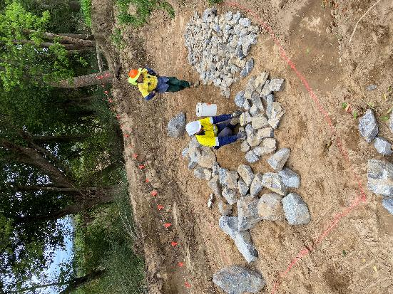  Figure 1 Sorting shot rock to test d50, Nambucca River, Bowraville September 2025 | 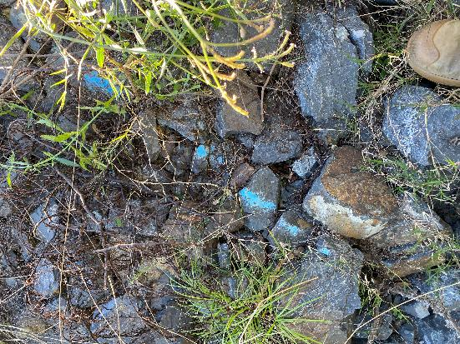  Figure 2 Witness mark showing small rock stable after flood event. Five Day Creek, Comara May 2024

Granular filter as an alternative to geotextile
Geotextile filter fabric is ubiquitous in rock revetment practice to prevent fine bank material from migrating through rock voids from both surface flows and ground water. Geotextile is well-tested, inexpensive and relatively simple to install and verify, but there exists an inherent tension with the concept of lining natural waterways with synthetic polymers and covering it in rock. Although there is a paucity of data on long term impacts, its use on large scales carries risks of microplastic contamination, and reduces the ability of plant roots to penetrate deeper in the soil profile where present. Further, a failure of the filter layer through exposure to puncture during installation, UV exposure after rock movement, or biological activity clogging pores, has been observed in practice.
Using guidance and specifications from Witheridge (2021), a granular filter layer was constructed using a 200 mm graded aggregate quarry rock 20-70mm under the armour layer in Kennaicle Creek (Figure 3). The aggregate was sized to bridge the gap between the native bank material (sandy loam) and the overlying rock without allowing fine particle migration as the standard approach in geotechnical applications but less commonly applied in bank revetment in NSW. The installation was simple, reduced the need for manual labour, and as a result costs were marginally higher than geotextile (~15%) although minor relative to the total project costs. Performance through subsequent flood events was comparable with adjacent geotextile-lined sections, with no evidence of fines migration, piping or undermining. The granular filter also provides a more stable substrate for vegetation establishment in the lower bank zone (Figure 4), although it’s unclear if roots have penetrated at this early stage.
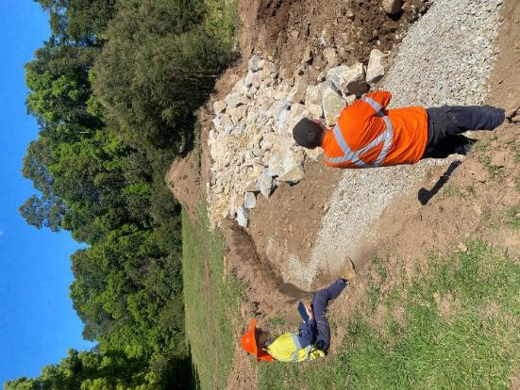  Figure 3 Granular filter with armour rock overlay at Kennaicle Creek, Missabotti, September 2024 | 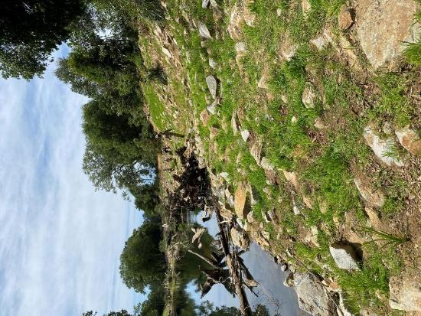  Figure 4 Soil filled revetment being planted on the Nambucca River, Bowraville November 2025

Large wood: enhancing habitat function and hydraulic influence
Large wood provides hydraulic roughness, pool formation, and structural complexity that rock revetment alone cannot replicate. Design guidance for anchoring wood in Australian streams is conservative, typically specifying substantial rock ballast, cable or timber piles. Cable and piles increase project cost and can be difficult to install. Cable also poses a safety risk if the structure fails, especially in public areas. A cabled structure can fail as a whole rather than log by log, and loose cable ends can trap or injure the public (Saldi-Caromile et al., 2004). Guidance from the US Pacific Northwest region advises cable should be avoided due to the risk of mass structural failure (Knutson & Fealko, 2014), though anecdotally it remains one of the most widely used anchoring methods in Australia. Timber piles require additional material and specialist machinery, and are only cost effective under specific site conditions. Heavy rock ballast reduces habitat value by burying the timber and filling voids in the structure, reducing the proportion of the log projecting into the channel and subsequently structural complexity and channel roughness.
Buoyancy, determined by timber density which varies between species and with moisture content, can be considered for reducing ballast while retaining stability, especially when actual density can be measured. Natural timber snags lodged in stream channels provide ample examples of stable wood without engineered anchoring if arranged together in messy log jam structures.
A recent large woody debris installation at Five Day Creek aimed to use passive anchoring both to enhance the wood’s function and reduce costs given the site’s long distance from materials. Rather than blanketing the structures in rock or using fixed anchors and cable, stability was designed through placing two logs together for additional friction; keying logs into rock between 1-1.5m; and hydraulic resistance from the wood volume and density itself, as tested by weighing the log underwater to measure buoyancy (Figure 5). Stability was monitored after multiple flood events, including ex-Tropical Cyclone Alfred. Wood remained stable at ballast below standard specifications, which commonly require two thirds of rock cover and one third of the log in the channel. Following ex-Tropical cyclone Alfred, surveys showed that the log installations remained in position despite high-velocity flows and extensive saturation of the soil over months (Figure 6). In some cases, channel changes during the flood improved rather than degraded performance through deposition behind the log, and an increase in channel cross-section through scour at the tip.
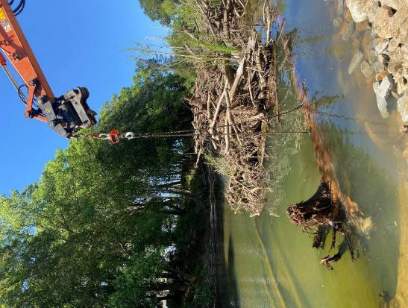  Figure 5 Weighing log with rootball to test buoyancy. Nambucca River, September 2025 | 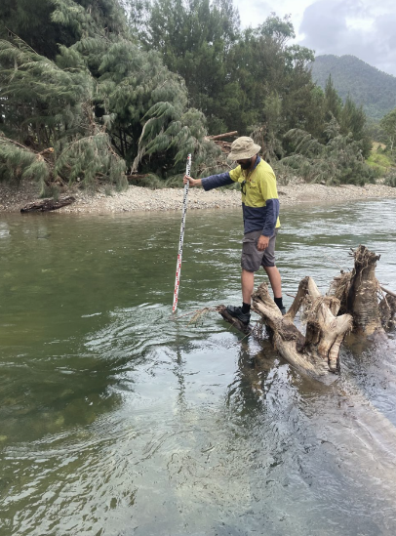  Figure 6 Scour from installed log after flood, ~ 1.4m deep, Five Day Creek, Comara, May 2025

Discussion

Limitations from technical guidance
While not prescriptive, the existing guidance on Australian river rehabilitation is critical to the practice. These resources establish sound design principles but are necessarily general. They cannot tell practitioners how conservative their thresholds are under the specific conditions of high-energy coastal NSW streams, or what the minimum intervention is, in terms of cost, scale and design, that will still create enough stability to allow the stream to heal.
Rutherfurd et al. (2000, p.9) wrote that 'by sharing, evaluating and recording the successes and failures of our stream rehabilitation efforts we will gain the confidence needed to begin roll back [sic] the many decades of degradation that our streams have suffered.' Twenty-five years later, the trials described here are a modest attempt to do exactly that.

The cost of conservative design and benefits of lighter treatment
Myopic and conservative design carries real costs within a constrained funding environment. At current North Coast prices, shot rock at $19/t represents a saving of approximately 59% on graded riprap at $46/t on rock material costs. At typical cross-sections of around 10 t per lineal metre, even a 2:1 shot-to-armour blend produces substantial savings that compound significantly at programme scale. The choice of material specification, and how conservative our approach, directly determines how much of the problem gets addressed in a given funding cycle.
Further, void-filled revetment creates a self-healing matrix with stronger mechanical interlock than uniform graded rock. Smaller void spaces support plant root penetration, improving vegetation, and creating a shaded ecosystem that becomes part of the rock structure over time. It has been observed that within 12 months under high rainfall conditions, the vegetation blankets the revetment and the rock is barely visible, which is more natural and aesthetic. A lighter treatment that performs adequately is therefore not just cheaper, it can be structurally resilient, ecologically productive, and integrate more naturally into the landscape.

Limitations and the case for structured experimentation
These are field observations from operational works, not controlled experiments. The sample sizes are small, sites differ in bank material and hydraulic context, and there were no randomised treatment sections. However, these observations offer real performance data from recent flood events, using materials and methods available to practitioners.
Rutherfurd et al. (2000, p.255) noted that post-project monitoring is essential ‘because we are, as yet, so uncertain about the effectiveness of stream rehabilitation works’, and that on the Broken River, scientific evaluation cost more than twice the structural works. The call for monitoring and field trials has not been widely answered in the two decades since. The trials described here represent a modest contribution to that evidence base, and an argument that such contributions can be embedded in operational practice without requiring dedicated research budgets.
These findings do not argue against engineering design guidance; they argue for not taking it at face value, but testing it. Current practice tends to default to conservative treatments, with limited feedback on whether that level of intervention is actually required. Building simple trials into real-world projects, and observing how they perform through real events, is a practical way to begin releasing the design ratchet towards proportionate, nature-based interventions.

Conclusions
Field observations from river rehabilitation works on the NSW mid-North Coast found that lighter interventions performed better than standard design assumptions predicted. Specific findings are:
- A vegetated revetment using shot rock blended with armour rock below baseline flows, and vegetated revetment above flows, performed comparably with graded riprap in terms of stability, with observed rock movement below standard sizing estimates, better vegetation establishment, and lower material costs.
- A 200 mm granular filter layer provided comparable fines separation to geotextile, with potential durability advantages in difficult installation conditions and a reduction in plastic used in river rehabilitation.
- Large wood remained stable through ex-Tropical Cyclone Alfred with ballast anchoring below standard specifications, providing complexity, pool formation and habitat.

Acknowledgements
The author acknowledges patient landholders, trusting clients and supportive colleagues at the NSW Soil Conservation Service, whose support made these field trials possible. The projects were delivered as part of the NSW River Rehabilitation Program, funded through Local Land Services in partnership with the Australian Government.

References
Knutson, M., & Fealko, J. (2014). Large Woody Material – Risk-Based Design Guidelines. U.S. Department of the Interior, Bureau of Reclamation, Pacific Northwest Region, Resource & Technical Services, Boise, Idaho, USA.
Rutherfurd, I. D., Jerie, K., & Marsh, N. (2000). A Rehabilitation Manual for Australian Streams, Volume 1. Cooperative Research Centre for Catchment Hydrology and Land and Water Resources Research and Development Corporation, Canberra.
Rutherfurd, I. D., Jerie, K., & Marsh, N. (2000). A Rehabilitation Manual for Australian Streams, Volume 2. Cooperative Research Centre for Catchment Hydrology and Land and Water Resources Research and Development Corporation, Canberra.
Saldi-Caromile, K., Bates, K., Skidmore, P., Barenti, J., & Pineo, D. (2004). Stream Habitat Restoration Guidelines: Final Draft. Washington Departments of Fish and Wildlife and Ecology, and U.S. Fish and Wildlife Service. Washington, USA.
Witheridge, G. (2021). Use of Rock in Waterway Engineering. Catchments and Creeks Pty Ltd, Bargara, Queensland.

