Natural Flood Management in eastern Australia: applying geomorphic
insights to enhance NFM outcomes in practice
Isabelle Flook¹, Misko Ivezich¹, Ian Rutherfurd^{1, 3}, Joanne Burton²
1 Alluvium Consulting, NSW, 2481. Email: isabelle.flook@alluvium.com.au
2 Council of Mayors (SEQ), QLD, 4000.
3. School of Geography, Earth & Atmospheric Science, The University of Melbourne.

Key Points
- The fundamental principles behind Natural Flood Management (NFM) comes from an understanding of the hydrological and hydraulic impacts that land uses changes have had on flooding processes and how we can redress them.
- NFM typically aims to influence hydrological and hydraulic processes via one (or more) of four mechanisms: 1) Increasing infiltration; 2) Slowing conveyance within channels by increasing hydraulic roughness; 3) Increasing floodplain storage; 4) Desynchronising sub-catchment flood peaks.
- Floodplain storage is critical to attenuating downstream flood peaks in large flood events; channel capacity significantly affects channel-floodplain connectivity and therefore the potential for floodplain storage.
- Managing ongoing channel enlargement is an under-recognised but potentially high-impact NFM intervention, with investigations in South East Queensland showing that channel enlargement over a ten-year period increased peak discharges by 10–15% in some systems.
- Backwater effects generated by valley constrictions (and other downstream hydraulic controls) can influence the effectiveness of NFM approaches; the effect of channel enlargement on flow conveyance in backwater zones becomes less pronounced with increasing flood magnitude.

Abstract
Conventional flood mitigation strategies in eastern Australia have largely relied on engineered infrastructure, including dams, levees and channelisation of waterways. These strategies can have adverse environmental impacts, and the latter approaches, which confine and accelerate flow velocities to reduce flood levels in targeted locations, can increase flood risk downstream. In recent years, a different approach has emerged called Natural Flood Management (NFM). NFM uses “natural” hydrological and biophysical processes to reduce flood risk, whilst delivering a range ecological and societal co-benefits.
Within NFM research and published guidelines to date, the impact of channel enlargement on flood flow conveyance has been largely overlooked. Four case study areas in South East Queensland were used to investigate the impact of erosional channel enlargement on downstream peak discharges. The LiDAR-based hydraulic modelling results indicate that erosional channel enlargement over a ten-year period increased peak discharges in some systems by approximately 10–15%. The findings also highlight that, where downstream hydraulic controls such as valley constrictions create backwater effects, the influence of channel enlargement on flow conveyance becomes less pronounced with increasing flood magnitude.
These geomorphic insights present an opportunity to enhance NFM outcomes in practice, by firstly aligning the pursuit of NFM outcomes with river rehabilitation more generally, and secondly, by considering geomorphic setting when prioritising placement of NFM interventions to maximise the hydraulic benefits they provide. The challenges associated with large-scale implementation of NFM, including secondary consequences of successful NFM, are also explored.

Keywords
Natural flood management; nature-based solutions for flood mitigation; channel enlargement; flow conveyance; riparian rehabilitation; geomorphology

Introduction
Eastern Australian catchments are experiencing increasingly extreme and intense rainfall events (CSIRO, 2024). Since colonisation, there have been widespread changes to catchments, floodplains and riparian zones that have altered hydrological and hydraulic processes. Extreme rainfall events, coupled with catchment degradation impacting flooding dynamics, have had dramatic and widespread implications for the health of our river ecosystems (extending to marine ecosystems), leading to major and prolonged water quality issues (NSW DPE, 2026), fish kills (NSW EPA, 2025) and habitat destruction. If we also consider the impact to property and infrastructure, extreme flooding is Australia’s most expensive natural disaster in terms of insured losses, with the annual cost having doubled in the last five years to $2.2 billion (Insurance Council of Australia, 2024).
Conventional flood mitigation strategies (excluding land use planning approaches) have typically relied on engineered infrastructure such as dams, levees, and channelisation of waterways. The latter strategies aim to confine and speed up the flow velocities to lower the flood level (called the flood stage) in desired locations, often with the aim of protecting populated areas or essential infrastructure, more often than not, contributing to higher flow velocities and elevated flood peaks downstream. Whilst dams can reduce the amount of water entering the river networks in flood events, they can have major long-lasting negative impacts on river systems by disrupting sediment transport dynamics, changing flow regimes and degrading aquatic habitats.
In recent years, a different approach has emerged called Natural Flood Management (NFM) – also referred to as ‘nature-based flood mitigation’. NFM uses “natural” hydrological and biophysical processes to reduce flood risk by typically slowing the movement of water downstream (i.e. reducing conveyance) (Lane, 2017; Prinsley et al., 2023; Fryirs et al., 2023; Water Technology, 2020). Unlike conventional structural approaches to flood mitigation, NFM approaches create landscape-scale changes that deliver a range of co-benefits for the environment, society and economy (Prinsley et al., 2023).

Overview of typical NFM approaches
Since colonisation, there have been widespread changes to catchments, floodplains and riparian zones across eastern Australia that have fundamentally altered hydrological and hydraulic processes, and consequently, flooding dynamics. Land use changes—including vegetation clearing, livestock, urbanisation, channel modifications and wetland drainage—have generally increased runoff volumes, reduced infiltration, accelerated flood wave celerity (speed at which a flood peak travels downstream) and elevated downstream peak discharges. The fundamental principles behind NFM comes from an understanding of these hydrological and hydraulic impacts on flooding processes and how we can redress them. NFM typically aims to influence hydrology and hydraulics via one (or more) of four mechanisms, summarised in Table 1.
Large-scale implementation of NFM is a costly exercise, and so it is important to understand the scale of influence that different NFM approaches can have on downstream flood peaks. Alluvium Consulting undertook an extensive literature review for Council of Mayors (SEQ) investigating the effectiveness of NFM approaches (Alluvium Consulting, 2024). Whilst NFM is an area of growing research in Australia, most research on NFM has occurred overseas, with the majority of research coming from the UK and Europe. Most evidence for the effectiveness of NFM interventions is based on studies that have modelled impacts in small catchments less than 10 km² (Nicholson et al., 2019; Wilkinson et al., 2019; Dadson et al., 2017), and extrapolating findings from smaller catchments to the larger catchments of eastern Australia must be done so with caution (Rinaldo et al., 1991; Pattison et al., 2014).
A key finding of the review was that the effectiveness of different NFM approaches varies depending on the scale of flood, as summarised in Table 1. Importantly, for large flood events, maintaining widespread channel–floodplain connectivity in mid- and upper-catchment areas is critical for facilitating floodplain storage and attenuating downstream flood peaks. In extreme flood events, desycnhronisation of sub-catchment tributary flows is critical (Lane, 2017), yet sub-catchment response will always vary with space and time depending on the distribution of the extreme rainfall event, making it difficult to ensure desynchronisation occurs (Pattison et al., 2014).

Table 1. A summary of NFM mechanisms, typical management approaches and the scale of flooding that they influence (Alluvium, 2024).
Mechanism | Management approach | Relevant scale of flooding
1) Increasing infiltration and storage in soils and headwaters | - Reforestation | Small flood events  ~ 1 to 10-year ARI
2) Slowing conveyance within channels by increasing hydraulic roughness | - Riparian revegetation  - Instream structures (e.g. leaky weirs or engineered log jams) | Small - moderate flood events equivalent to bankfull flow*  Variable, but estimated at  ~ 1 to 10-year ARI
3) Re-engaging floodplains and increasing floodplain storage  (i.e. temporary retention of floodwaters on floodplains, reducing the volume of water moving downstream) | - Wetland rehabilitation  - Levee removal  - Overland flow interception bunds (‘floodplain bunds’)  - Floodplain revegetation | Large flood events  ~ 20 to 100-year ARI events
4) Desynchronisation of sub-catchment flood peaks  (i.e. slowing and staggering flood waves from different sub-catchments to prevent their coincidence downstream) | - Coordinated, catchment-scale interventions, including widespread floodplain re-engagement in mid and upper catchment areas. | Extreme flood events  ~100-year ARI events
* Bankfull flow varies depending on the geomorphic characteristics of the system, and can be up to 50-year ARI in macrochannel systems (Fryirs et al., 2023; Arash et al., 2023)
A river’s cross-sectional geometry strongly influences hydraulic roughness interactions (see (2) in Table 1) and channel-floodplain connectivity (see (3) in Table 1), yet geomorphic processes that contribute to channel enlargement have largely been overlooked in NFM research and published NFM guidelines to date (Prinsley et al. 2025). Limiting channel enlargement warrants closer consideration as a potential NFM approach and that is the subject of the remainder of this paper.

Impacts of channel enlargement on flood flow conveyance
Many alluvial channels along the east coast of Australia have undergone substantial incision and widening in response to land use changes that altered catchment hydrology, increased hydraulic forces, and reduced channel resistance. These land use changes include clearing of native forest, urbanisation, and various forms of channelisation (ironically) historically undertaken for flood mitigation purposes, including desnagging, channel straightening, and riparian vegetation clearing (Prosser et al., 2001; Rutherfurd, 2000). Although much of this channel enlargement occurred during the nineteenth and twentieth centuries, channel enlargement is still ongoing in many rivers across eastern Australia.
At the cross-sectional scale (Figure 2), channel enlargement is typically characterised by:
- An increase in hydraulic radius;
- A reduction in hydraulic roughness due to loss of vegetation and simplification of channel form (e.g. loss of inset geomorphic features, and channel straightening).
Although the changes may occur incrementally, they can significantly affect flow conveyance over decadal time scales – an example of erosional channel enlargement in the Lockyer Valley in South East Queensland is shown in Figure 1. Channel enlargement typically increases flood flow conveyance and reduces channel-floodplain connectivity (i.e. overbank flows become less frequent) and therefore floodplain storage, which has a strong influence on flood peak attenuation in large flood events (Table 1). Together, these changes contribute to more efficient downstream transfer of floodwaters (increased flood wave celerity), which can result in higher peak discharges and higher flood levels downstream. We argue that long-term channel enlargement may exert a greater influence on downstream flood risk than the NFM approaches summarised in Table 1. Furthermore, the effectiveness of NFM could be enhanced by not only increasing floodplain storage and hydraulic roughness, but by also addressing channel degradation processes that lead to channel enlargement.
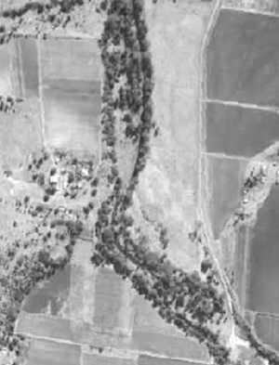  1951 – Blackfellow Creek at Mount Sylvia | 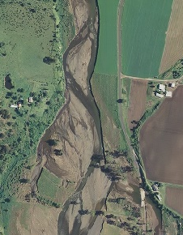  2013 – Blackfellow Creek at Mount Sylvia
Figure 1. Example of erosional channel enlargement in a stream in Lockyer Valley in South East Queensland

Case study investigations
The impact of channel enlargement on downstream flood behaviour was investigated by Alluvium Consulting through four case study areas within South East Queensland – Blackfellow Creek, Laidley Creek, Oxley Creek and Upper Warrill Creek (Alluvium Consulting, 2025). All four case study catchments experienced major flooding in 2010/2011, 2013, 2017 and 2022. These floods not only had profound impacts on the local communities, but they also contributed to channel enlargement due to erosion (Table 2). For each case study, two LiDAR datasets captured approximately 10 years apart (between 2009 and 2023) were used to create hydraulic models (‘pre-erosion’ and ‘post-erosion’) and analyse changes in flood conveyance related to the geomorphic change.
Table 2. Summary of channel enlargement mechanisms and magnitude for the four case study areas.
Case study | Channel enlargement mechanisms | Dominant geomorphic processes | Degree of channel enlargement
Blackfellow Creek | Extensive channel widening through bank scour and large-scale meander migration, with a major chute cutoff causing additional channel enlargement and sediment mobilisation. Enlargement occurred over several kilometres. | Lateral migration, bank erosion and chute cutoff | High
Laidley Creek | Progressive channel incision within the inset channel accompanied by channel widening and loss of the narrow riparian corridor. Enlargement reflects both deepening and widening of the active channel. | Incision and widening | High
Oxley Creek | Very substantial channel widening following historical sand extraction and subsequent channel instability. The channel more than doubled in size and conveyance capacity at representative cross sections. | Anthropogenically triggered widening and channel metamorphosis | Very high
Upper Warrill Creek | Widespread bank scour, meander migration and channel widening with localised areas of both erosion and deposition, producing variable increases and decreases in channel cross-sectional area along the reach. | Lateral migration with sediment redistribution | Moderate to high

The assessment results for each case study catchment are summarised below:
- In the Laidley Creek model, channel enlargement resulted led to increases in peak flow, with the impact most evident in the 2% AEP event, where peak flows increased by close to 14% (Figure 3). In the events modelled, the flood peak arrived between 30 and 90 minutes earlier due to more efficient conveyance.
- In contrast, at Blackfellow Creek, changes to peak flows were negligible in the larger flood events and largest in the 50% AEP event, where flow had increased by ~4% in the 50% AEP event. The largest change in timing (flood wave celerity) was observed in the 50% AEP event, with the flood peak arriving 15 minutes earlier in the post-erosion case.
- In Upper Warrill Creek, there was an increase in peak flow of 9% in the 2% AEP event. Channel enlargement resulted in an increase in channel conveyance due to a reduction in floodplain storage during this event.
- In the Oxley Creek case study, there was less change in flooding behaviour observed compared to the other case studies. This is likely due to the shorter length of reach impacted by erosion and the large backwater effect associated with a valley constriction and Greenwood Lakes.
Pre-erosion channel form | Post-erosional channel enlargement
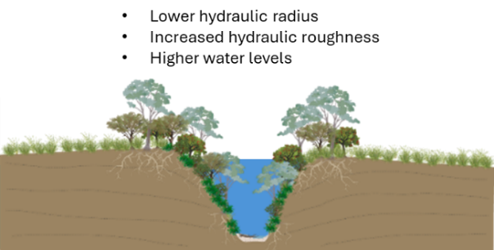 | 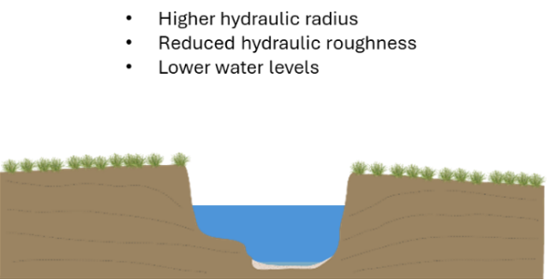
 | 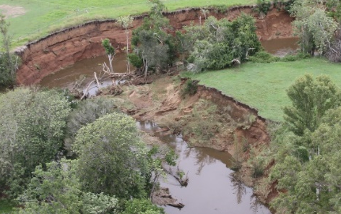
Figure 2. The impacts of erosional channel enlargement on key hydraulic processes
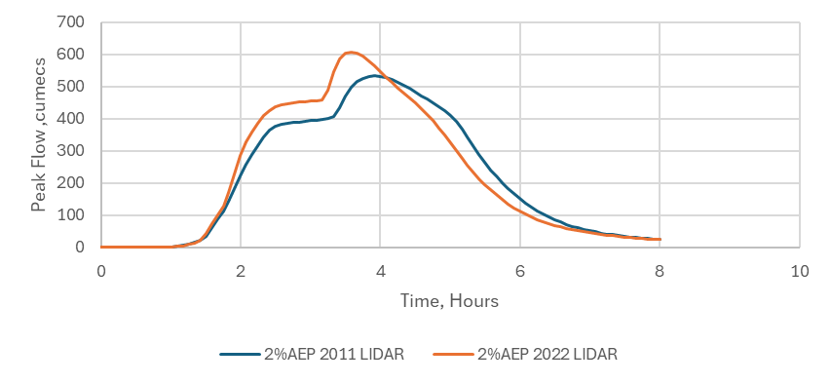
Figure 3. Example from Laidley Creek in south east Queensland showing a 14% increase in peak discharge for the 2% AEP event (Alluvium Consulting, 2025).
Given that many of these systems have been enlarging over the past 50–100 years, it is likely that the cumulative impacts of channel enlargement on flow conveyance and flood behaviour are significantly greater over longer timescales.
Key findings from the case study investigations:
- Reach-scale channel enlargement due to erosional channel change can significantly increase flood peaks in large flood events, with a close to 14% increase in peak flow observed for Laidley Creek in the 2% AEP event solely due to erosional channel change that occurred over an 11-year period (between 2011 and 2022).
- The difference in results for each of the case studies highlights that channel-floodplain connectivity strongly influences downstream flood peaks; the greatest increase in downstream flood peaks occurred when the erosional channel change caused a reduction in floodplain engagement (resulting in a significant reduction in floodplain storage).
- Where backwater effects occur (due to valley constrictions or other geomorphic controls), the impact of channel enlargement on flood peaks is much less pronounced, as was observed in the Oxley Creek case study.

Opportunities to apply geomorphic insights to enhance NFM outcomes in practice

Manage threats contributing to ongoing channel degradation
Effective NFM in eastern Australian catchments requires addressing channel degradation processes that lead to channel enlargement. Channel enlargement is often initiated by some form of disturbance e.g. riparian vegetation removal, unrestricted livestock access, chute cutoff, gravel/sand extraction etc. The disturbance can trigger localised streambed lowering, creating a sharp change in bed elevation known as a knickpoint. This forms an over-steepened section of channel that is no longer in equilibrium with upstream and downstream reaches. Flow energy becomes concentrated at this point, increasing shear stress on the bed and banks and driving active erosion. As a result, the knickpoint migrates upstream through headward erosion, progressively propagating a deepening and widening process through the channel network.
Arresting long-term channel degradation therefore involves a) managing threats that could initiate channel disturbance; and b) addressing geomorphic processes contributing to ongoing channel enlargement. Examples of management interventions include a) restricting livestock access, particularly in areas that are highly sensitive to disturbance, such as valley fill/swampy meadows, and b) stabilising the stream bed where there is an actively migrating knickpoint.
As we witness widespread catchment degradation, protecting any remaining ‘intact’ watercourses is increasingly critical. In the context of NFM, this means prioritising the protection of areas currently functioning optimally in terms of their flow retention capacity; areas of intact valley fill and chain-of-ponds systems, and alluvial river reaches in good geomorphic condition (not yet incised or overwidened) with good channel-floodplain connectivity. These ‘intact’ systems already provide flood attenuation benefits, therefore the most resource-efficient and cost-effective approach to applying NFM at scale is to protect these systems by identifying and actively managing threats.

Implement large-scale riparian rehabilitation
To date, there has been a strong focus on the role of riparian revegetation in NFM with respect to slowing flow conveyance by providing hydraulic roughness, however, the role of vegetation in limiting erosional channel change and encouraging geomorphic recovery (Arash et al., 2023) must be emphasized.
Our observations and research show that, in comparable streams exposed to large flood events, those cleared of native vegetation undergo significantly greater channel enlargement than those that have been revegetated over time (Alluvium, 2011; Brooks et al., 2025). High-quality, structurally diverse native riparian vegetation—established through targeted revegetation programs—can play a critical role in reducing the occurrence, extent, and severity of flood-induced channel enlargement. Therefore, one of the most effective NFM approaches is riparian rehabilitation—not simply to increase hydraulic roughness, but to slow, halt, or reverse the trajectory of channel enlargement.
A study by Agnew and Fryirs (2022) presents a ‘prioritisation protocol’ that advocates moving away from ad hoc and reactive river rehabilitation and flood recovery programs in favour of adopting a more cost-effective approach that focuses on enhancing natural recovery processes of river systems by prioritising rehabilitation of reaches with ‘high recovery potential’ adjacent to ‘intact’ reaches, thereby expanding and strengthening the intact reaches to create continuous corridors of structurally diverse native riparian vegetation.

Prioritise the placement of NFM where hydraulic outcomes are likely to be most influential
The extent to which channel enlargement influences flow conveyance can be influenced by geomorphic setting; it is important to identify where backwater zones readily develop, as the effect of channel enlargement in these locations becomes less pronounced in large flood events.
A ‘backwater effect’ occurs when a downstream channel control such as a valley constriction causes flood flows to ‘back up’ (water levels rise and flow velocities reduce) upstream of that constriction. Often, a certain flow stage (or ‘threshold’) is required before a constriction creates a backwater zone (Figure 2). Channel enlargement tends to have a less pronounced effect on flood flow conveyance in backwater-controlled areas because flood behaviour in these areas is controlled less by the local channel capacity and more by the downstream hydraulic controls. Examples of hydraulic controls include bridges, weirs, dams and valley constrictions.
The same principles could apply to the relative effect of in-channel and floodplain hydraulic roughness; where backwater effects occur, the effect of hydraulic roughness in slowing flow velocities is likely to be less pronounced.
Understanding the influence of hydraulic controls can help target reaches where NFM interventions will have the most impact, rather than in locations where hydraulic outcomes are likely to lessen with increasing flood magnitude.

Challenges

Implementation challenges
Large-scale riparian rehabilitation is essential to slowing, halting,and reversing the trajectory of channel enlargement. However, the success of riparian rehabilitation projects most often depends on landholder goodwill, including setting aside productive land for ecological functions and agreeing to change land management practices. As such, many projects are implemented on a small scale, with narrow riparian buffer widths. Narrow buffers are difficult to maintain, prone to edge effects, and can suffer from high predation and competition pressures, which reduce the success of vegetation establishment—especially for sensitive native species.
From both an ecological and hydraulic perspective, wider, continuous riparian corridors of high-quality, structurally diverse native vegetation are needed to meaningfully reduce erosion and ultimately slow flood conveyance. However, the current fragmented and voluntary model of riparian management has largely failed to achieve these outcomes at the reach or catchment scale across eastern Australia.
Successful implementation of NFM at scale will require new economic models that more fairly distribute the costs and benefits of large-scale riparian rehabilitation. These models should recognise the public value of healthy riparian corridors and provide direct support to landholders who protect and restore these areas in recognition of the ecosystem services they provide. Potential mechanisms include:
- Targeted financial incentive programs,
- Leasing arrangements for riparian land,
- Stewardship schemes for managing native vegetation as a farm enterprise, and
- Strategic land buybacks in high-priority areas.
Without structural support for landholders, NFM is unlikely to move beyond small-scale, opportunistic efforts, limiting its potential to deliver meaningful flood resilience, water quality improvement, and biodiversity outcomes.

Conclusions
Natural Flood Management in eastern Australia must account for geomorphic processes, as well as hydrological and hydraulic processes. Channel form is not fixed: ongoing enlargement can increase conveyance, reduce channel–floodplain connectivity and floodplain storage, accelerate flood-wave movement and increase downstream flood peaks. In the South East Queensland case studies, channel enlargement over little more than a decade increased modelled peak discharges by up to approximately 14%.
These effects vary with geomorphic setting. Where enlargement reduces floodplain engagement, downstream flood peaks may increase substantially. In reaches affected by valley constrictions or other hydraulic controls, however, backwater effects can limit the influence of local channel capacity and roughness, particularly during larger floods.
Effective NFM should therefore combine measures that increase infiltration, roughness and floodplain storage with actions that protect intact waterways, arrest channel degradation and promote geomorphic recovery. Large-scale riparian rehabilitation is especially important because vegetation can both increase hydraulic resistance and limit further channel enlargement.
Successful NFM will inevitably redistribute water, sediment and flood impacts throughout catchments. These consequences must be anticipated through careful assessment, monitoring, adaptive management and appropriate institutional arrangements.

References

Agnew and Fryirs, 2022. Agnew, D., and Fryirs, K. (2022). Identifying corridors of river recovery in coastal NSW Australia, for use in river management decision support and prioritisation systems. PLoS ONE
Alluvium Consulting. (2011). An assessment of the impact of riparian revegetation on stream erosion during floods in Victoria. Report to Department of Sustainability and Environment, Victora.
Alluvium Consulting. (2024). DRFA Natural Flood Management Scoping Investigations: Background Review. Report prepared for Council of Mayors SEQ.
Alluvium Consulting. (2025). SEQ Strategic River Resilience Works program: Preliminary flood impact assessments due to erosion. Report prepared for Council of Mayors SEQ.
Arash, A.M., Fryirs, F. and Ralph, TJ. (2023). Detection of decadal time-series changes in flow hydrology in eastern Australia: Considerations for river recovery and flood management. Earth Surface Processes and Landforms. 48(15). https://doi.org/10.1002/esp.5694
Brooks, A.P, Spencer, J.S., Agnew, D. and Daley, J. (2025). Sediment pollution sources to the Richmond River: Final report for the Richmond River Estuary Coastal Management Program Stage 2.1 Strategic Prioritisation for on-ground works. Precision Erosion and Sediment Management Group, Griffith University.
CSIRO. (2024). Understanding the causes and impacts of flooding. https://www.csiro.au/en/research/disasters/floods/Causes-and-impacts
Fryirs, K., Zhang, N., Ralph, T.J. & Arash, A.M. (2023) Natural flood management: Lessons and opportunities from the catastrophic 2021–2022 floods in eastern Australia. Earth Surface Processes and Landforms, 48(9), 1649–1664. https://doi.org/10.1002/esp.5647
Insurance Council of Australia. (2024). News release: New data shows long-term cost of extreme weather. https://insurancecouncil.com.au/wp-content/uploads/2024/08/240819-New-data-shows-long-term-cost-of-extreme-weather.pdf
Lane, S.N. (2017) Natural flood management. Wiley Interdisciplinary Reviews: Water, 4(3), e1211. Available from: https://doi.org/10.1002/wat2.1211
Nicholson, A., O'Donnell, G., Wilkinson, M. & Quinn, P. (2019). The potential of runoff attenuation features as a Natural Flood Management approach. Journal of Flood Risk Management. 13. 10.1111/jfr3.12565.
NSW DPE. (2026). Flood recovery program - east coast project water quality dashboard. https://naturalhazardsscience-hub.seed.nsw.gov.au/flood-impacts-and-recovery/flood-recovery-program-east-coast-project-water-quality-dashboard
NSW EPA (2025). NSW Government response to fish kills in Northern Rivers. https://www.epa.nsw.gov.au/news/epamedia/250326-nsw-government-response-to-fish-kills-in-northern-rivers
Pattison, I., Lane, S.N., Hardy, R.J., Reaney, S.M. (2014). The role of tributary relative timing and sequencing in controlling large floods. Water Resour Res. 50:5444–5458.
Prinsley, R., Sedighkia, M., Herath, P., Alexandra, J., Webster, T., Menzies, K., Croke, B., Hunt, S., Smith, J., Cordova, A., Falconer, N., Manning, M. & Wissing, K. (2025). Nature-based Solutions for flood mitigation in Australia-3 volumes, ANU
Prosser, I. P., Rutherfurd, I. D., Olley, J. M., Young, W. J., Wallbrink, P. J., & Moran, C. J. (2001). Large-scale patterns of erosion and sediment transport in river networks, with examples from Australia. Marine and Freshwater Research, 52(1), 81-99.
Rutherfurd, I. (2000). Some human impacts on Australian stream channel morphology. River management: the Australasian experience, 11-49.
Simon, A., & Darby, S. E. (2002). Effectiveness of grade-control structures in reducing erosion along incised river channels: the case of Hotophia Creek, Mississippi. Geomorphology, 42(3-4), 229-254.
Water Technology. (2020). Ipswich Integrated Catchment Plan: Technical Evidence Report. Report to Ipswich City Council.
Wilkinson, M. E., S. Addy, P. F. Quinn, and M. Stutter. (2019). Natural Flood Management: Small-Scale Progress and Larger-Scale Challenges. Scottish Geographical Journal. 135(1–2), 23–32. https://doi.org/10.1080/14702541.2019.16105

